ATTENTION STUDENT: If you are found to have plagiarized any part of your PsychSim assignment, you will receive a 0 for the assignment and may be formally reported to KPU. If you wish to quote the source provided or any other webpage, you MUST cite the source using APA formatting. To avoid plagiarism, write all answers in your own words.

For more information on plagiarism and cheating, please visit https://libguides.kpu.ca/academicintegrity/plagiarism to study the videos and tutorials available.
​
KPU's policy on academic integrity is found at https://www.kpu.ca/student-rights-responsibilities/academic-integrity

Name this file using the following format:
LastnameFirstname_Section_AssignmentName
For example: SmithJohn_A54_AuditorySystem

PsychSim Online: The Auditory System
Name: _______________________ Student ID: _________________
Course/Section: _______________ Instructor: __________________

Sound and the Ear
Watch this video to answer the following questions:
https://www.youtube.com/watch?v=Ie2j7GpC4JU

- How does sound travel through the air?

- Highlight or underline the option for each of the points on the graph
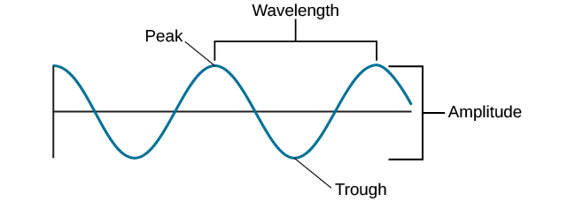
A
B

Point A represents the
  - Amplitude
  - Distance
  - Frequency
  - Sound
  - Wavelength
Point B represents the
- Amplitude
- Distance
- Frequency
- Sound
- Wavelength

- A high-pitched sound indicates a higher ______
A low-pitched sound indicates a lower ______
A louder (or higher volume) sound indicates a higher ______
A quieter (or lower volume) sound indicates a lower ______

- Match the three main regions of the ear to their associated functions and components.

___ Middle Ear A. Bony labyrinth that contains the vestibule, the
semicircular canals, and the cochlea

___ External Ear B. Focuses the pressure of sound waves, and consists of the
Malleus, Incus, and Stapes

___ Inner Ear C. The Pinna or Auricle catches the sound waves and
passes them along deeper through the auditory canal

- The Eardrum is part of the _______________ (Inner/Middle/External) Ear

- Why do only some fibers inside the cochlea move when sound is detected?

