ATTENTION STUDENT: If you are found to have plagiarized any part of your PsychSim assignment, you will receive a 0 for the assignment and may be formally reported to KPU. If you wish to quote the source provided or any other webpage, you MUST cite the source using APA formatting. To avoid plagiarism, write all answers in your own words.

For more information on plagiarism and cheating, please visit https://libguides.kpu.ca/academicintegrity/plagiarism to study the videos and tutorials available.
​
KPU's policy on academic integrity is found at https://www.kpu.ca/student-rights-responsibilities/academic-integrity

Name this file using the following format:
LastnameFirstname_Section_AssignmentName
For example: SmithJohn_A54_AuditorySystem

PsychSim Online: Correlation
Name: _______________________ Student ID: _________________
Course/Section: _______________ Instructor: __________________

This worksheet examines the use of scatterplots to visualize positive and negative relationships.

Watch the following videos to answer the questions:
- https://www.youtube.com/watch?v=jUPkkiW-Q80
- https://www.youtube.com/watch?v=gxSUqr3ouYA

- Highlight, bold, or underline the correct answer to describe the relationships defined below.

When both variables increase or decrease at the same time, the relationship is said to be
- Positively correlated
- Negatively correlated
- Uncorrelated
When one variable increases, the other decreases. This relationship is said to be
- Positively correlated
- Negatively correlated
- Uncorrelated
If there is no relationship between the variables, the relationship is said to be
- Positively correlated
- Negatively correlated
- Uncorrelated

- The numerical representation or the calculation of the strength of the correlation is called the __________

- Fill in the following table with the correct type of relationship (Positive correlation, negative correlation, or uncorrelated) and drag the appropriate scatterplot into the table.

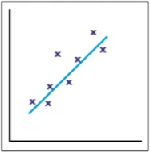
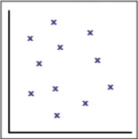
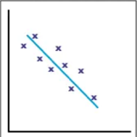

Example | Type of relationship | Scatterplot (drag from above)
Dr. June Juniper found that the more brownies a dog eats, the shorter its lifespan is.
A study was done that found that students who got more sleep received lower grades.
Dr. Maxine Maxwell found that there is no relationship between the weather and earthquake intensity.
Dr. Joe Java examined the relationship between drinking coffee and reaction time, and found that the more coffee a person drank, the faster their reaction time (in seconds).

- Identify the strength (weak/strong) and direction (positive/negative) of the following
Example | Strength (weak/strong) | Direction (positive/negative)
.73
-1.0
.20
-.091
.91
0.0

- Correlation does not equal causation. Provide your own example to demonstrate this fact.

- Why are correlations used if they can not provide a cause-effect conclusion? Provide an example.

For more practice identifying the relationships in scatterplots, visit
https://www.khanacademy.org/math/ap-statistics/bivariate-data-ap/scatterplots-correlation/e/positive-and-negative-linear-correlations-from-scatter-plots

https://www.khanacademy.org/math/ap-statistics/bivariate-data-ap/scatterplots-correlation/e/interpreting-scatter-plots

