ATTENTION STUDENT: If you are found to have plagiarized any part of your PsychSim assignment, you will receive a 0 for the assignment and may be formally reported to KPU. If you wish to quote the source provided or any other webpage, you MUST cite the source using APA formatting. To avoid plagiarism, write all answers in your own words.

For more information on plagiarism and cheating, please visit https://libguides.kpu.ca/academicintegrity/plagiarism to study the videos and tutorials available.
​
KPU's policy on academic integrity is found at https://www.kpu.ca/student-rights-responsibilities/academic-integrity

Name this file using the following format:
LastnameFirstname_Section_AssignmentName
For example: SmithJohn_A54_AuditorySystem

PsychSim Online: EEG & Sleep Stages
Name: _______________________ Student ID: _________________
Course/Section: _______________ Instructor: __________________

Watch these two videos to answer the following questions:
Sleep and dreams: https://youtu.be/iWo90uxkNM0
Stages of sleep: https://youtu.be/rMHus-0wFSo

True or False
For each of the following questions, indicate whether they are true or false. If they are false, rewrite the statement below it to make it correct.

- EEG stands for “Electrical Energy Graph”

- Sufficient sleep is necessary to promote adequate mental function throughout the day

- Sleep hinders the body’s growth process

- An EEG measures blood flow to the brain

- According to the video, you spend about 6 years of your life dreaming

- Your brain is dormant while you sleep

- Fill in the following table with the correct sleep stage (Stage 1, Stage 2, Stage 3, or REM) and drag the appropriate sleep stage graph into the table.

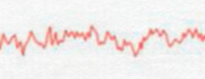
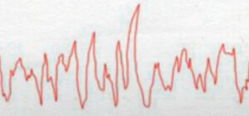
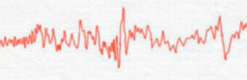
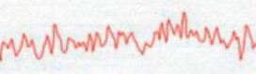

Definition | Sleep Stage | Graph
Low frequency, high amplitude delta waves are characteristic of this stage. Also known as slow-wave sleep, or deep sleep.
Rapid brain activity, represented by high-frequency waves (sleep spindles), and also has characteristic K-complexes
Brain activity resembles waking activity. This stage is where the most vivid dreams happen
Low amplitude, high frequency waves. Hypnagogic sensations can occur in this stage.

Multiple Choice
Select the answer that best matches the examples of sleep disorders.

Ahmad is often tired but has significant problems falling asleep. Even if he does fall asleep, he has trouble staying asleep. Which sleep disorder best matches Ahmad’s problem?
- Insomnia
- Narcolepsy
- Night terrors
- Sleep apnea

Ainsley was sitting in the food court at the local mall with her friend Alex when she suddenly fell asleep without any warning. This is not the first time this has happened. She is often overwhelmed with excessive sleepiness in the daytime and sometimes has sudden loss of muscle tone (or cataplexy). Which sleep disorder best matches Ainsley’s problem?
- Insomnia
- Narcolepsy
- Night terrors
- Sleep apnea

When Angelica was a child, her parents were often woken up by her screaming and trashing and found her asleep but covered in sweat and her heart racing. When they woke her up, Angelica would not remember any of the episodes nor did she recall any bad dreams. Which sleep disorder best matches Angelica’s problem?
- Insomnia
- Narcolepsy
- Night terrors
- Sleep apnea

Antonio visited a sleep specialist to find out why he was tired all the time. The doctor ran some tests and found out that Antonio tends to temporarily stop breathing while he is asleep, which was constantly waking him up. Which sleep disorder best matches Antonio’s problem?
- Insomnia
- Narcolepsy
- Night terrors
- Sleep apnea

Short Answer
- The second video describes five theories or ideas for why we dream. Select one of them and write about it in your own words. You may also provide examples of dreams that can be explained by the theory or idea.
  - Wish fulfilment
  - Information processing theory
  - Physiological function theory
  - Cognitive development
  - Neural activity models

