ATTENTION STUDENT: If you are found to have plagiarized any part of your PsychSim assignment, you will receive a 0 for the assignment and may be formally reported to KPU. If you wish to quote the source provided or any other webpage, you MUST cite the source using APA formatting. To avoid plagiarism, write all answers in your own words.

For more information on plagiarism and cheating, please visit https://libguides.kpu.ca/academicintegrity/plagiarism to study the videos and tutorials available.
​
KPU's policy on academic integrity is found at https://www.kpu.ca/student-rights-responsibilities/academic-integrity

Name this file using the following format:
LastnameFirstname_Section_AssignmentName
For example: SmithJohn_A54_AuditorySystem

PsychSim Online: My Head is Spinning
Name: _______________________ Student ID: _________________
Course/Section: _______________ Instructor: __________________

Watch this video to answer the following questions: https://www.youtube.com/watch?v=xW8JPJO9-VI

True or False
For each of the following statements, indicate whether they are true or false. If they are false, rewrite the statement below it to make it correct.

- Mental rotation is the process of imagining an object rotating in space.

- Women and girls allegedly perform better on mental rotation tasks than men and boys.

- Gender differences in mental rotation tasks was measured only in the United States and Canada.

Matching
- Fill in the following table with the correct term (Concept, Concept hierarchy, or Category) and drag the appropriate example into the table.

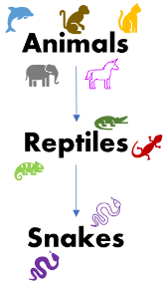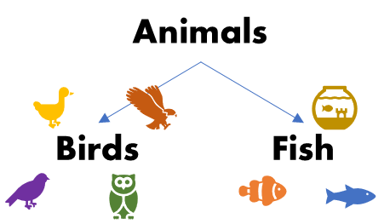

Definition | Term | Example
Mental grouping of events, objects, or people

Organizes concepts around one concept they all have in common

Arrangement of related concepts from general to specific (or from specific to general)

- Provide your own example of a concept hierarchy.

Visit this link to complete the Mental Rotation Test and record your results below:
https://rpsychlab.shinyapps.io/MentalRotation/

Accuracy score: /14
Average Reaction Time: .

- Do you think the mental rotation should be relevant when examining intelligence? Why or why not?

- Other than gender or sex differences, what variables do you think would predict a high score on the mental rotation test?

Watch this video to answer the following questions: https://www.youtube.com/watch?v=9xTz3QjcloI

- In your own words, discuss whether intelligence should be ranked on one single scale (e.g., the g-factor) or on multiple scales (e.g., multiple intelligences).

- Do you think emotional intelligence should be considered a part of general intelligence? Why or why not?

- In your own words, explain why is screening for intelligence so controversial.

