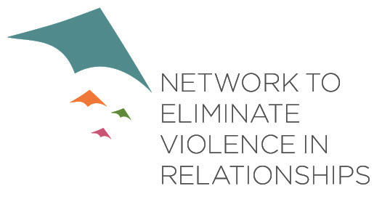
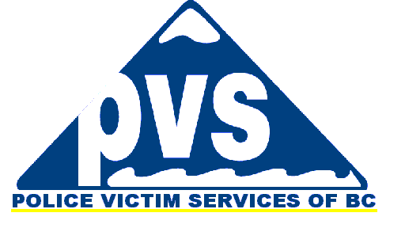
9th Annual Conference
NETWORK TO ELIMINATE VIOLENCE IN RELATIONSHIPS
October 31 & November 1, 2019
Kwantlen Polytechnic University Campus
12666 72 Ave
Surrey, BC V3W 2M8
Call for Presentations

NEVR presents Safe Communities: Voices from the Shadows

Network to Eliminate Violence in Relationships (NEVR) is pleased to issue a Call for Presentations for the 2019 Conference. NEVR is a cross sectoral committee consisting of over 50 organizations from policing, education, government and nonprofit in the Vancouver Lower Mainland. We strive to raise awareness and promote prevention and service initiatives by educating communities on how to reduce and eliminate violence in relationships. This year our theme will be “Safe Communities: Voices from the Shadows” which aims to bring together frontline staff and people in marginalized social positions who often do not have a platform to communicate their ideas and learn from each other. This year’s conference will focus on issues relevant to youth, indigenous people, LGBTQ+, seniors, refugees, and immigrants and the anti violence sector. We are seeking presentations from people with lived experience, educators and knowledgeable personnel who have an interest in sharing their expertise and evidence based best practices with our conference delegates.

Our conference subthemes are issues unique to populations such as: youth, Indgenous peoples, LGBTQ+, seniors, refugees, and immigrants. Examples of broad topic ideas are below:

- Abuse and neglect  - Co-morbidities | - Innovative practices supporting healthy families
- Housing | - Reconciliation and Anti Violence
- Recognizing resiliency  - Prevention programs | - Addressing vulnerable populations  - Trauma informed care
We will also be sharing on our Community Champions Toolkit at this conference. It is a resource that has been designed to provide awareness and information on how best to recognize the signs of relationship violence, how to safely respond to that violence and how to support someone experiencing violence. It is available in English/Punjabi/Cantonese.

Submission Deadline: July 31, 2019
Please submit completed word format application to
The Network to Eliminate Violence in Relationships by e-mail
E-mail: NEVR@KPU.ca

General Information:
Application for Presentations:
Primary Presenter:
Name:
Organization:
Address:
City: |  |  |  |  |  |  | Province:
Postal Code: |  |  |  |  |  |  |  | Phone:
Fax: |  |  |  |  | E-mail:
Secondary presenter: (If Applicable)
Name:
Organization:
Address:
City: |  |  |  |  |  |  | Province:
Postal Code: |  |  |  |  |  |  |  | Phone:
Fax: |  |  |  |  | E-mail:

Presentation Title:

Presentation Abstract: Please include the following information:
- Presentation Abstract: A description of your presentation, (Max. 250 words)

- Biographical Information: Brief description of each presenter. Provide background information/experience related to the presentation (50 words).
.

Type of Workshop: Lecture Panel Other, pls. specify:
** Please note that all presentations will be 1 hour & 15 minutes in length**

Please provide a brief outline of your presentation experience(s):

Audio Visual and Set up Requirements:
Do you have any special needs or set–up requirements? Yes No
If yes, please specify:
Do you require any audio-visual equipment or set-up? Yes No
PowerPoint (LCD) Projector ONLY Flip Chart and Markers
PowerPoint (LSD) Projector and Computer Screen
VHS VCR and TV DVD Player
Overhead Projector Other:
If other, please specify:

Scheduling:
Please specify your preference for your workshop presentation.
Thursday, October 31, 2019: Morning Afternoon
Friday, November 1st, 2019: Morning Afternoon
Are you willing to present more than one session if your workshop is full? Yes No

Will you have handouts or other materials for workshop participants? Yes No
If yes, are you able to provide your own photocopies? Yes No
Are you able to provide NEVR an electronic copy of your presentation and handouts?
Yes No

Please submit the word format application to: NEVR • NEVR@kpu.ca • Deadline: July 31, 2019.

