Electric car race 2024
Teams will design, build and bring to the competition, a car to be powered by two AA batteries. The car must carry four (4) standard 355 mL cans of Coca Cola down a 1.5 m wide course, to the finish line 7 m from the start line.
This is NOT a timed event. Two cars at a time will race, and the first car across the finish line is the winner of that heat. The winner advances to the next round. The overall winner of the block will return at the end of the day to race in the finals.
Notes
- The cars must be built by the teams. Parts may be purchased or harvested from toys, etc. sources but ready-made cars may not be raced.
- The cars must race using the batteries provided by race organizers, similar to these in the image.
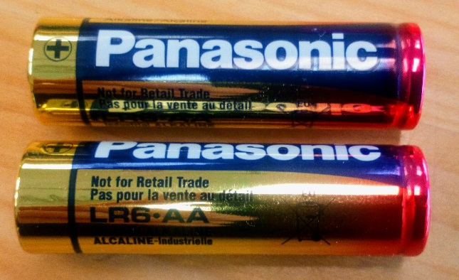
- Fresh batteries may be requested after each heat.
- The cars must be cars: i.e. wheeled vehicles.
- Cars not meeting the spirit of the rules will be disqualified. If in doubt, please ask in advance.

