Name: ______________________________ ID:_______________________

Course: PSYC 1100 Section:______ Instructor:____________________
DESCRIPTIVE STATISTICS

This activity introduces you to the basic statistics that researchers use to summarize their sets of data.

The numbers below represent the scores of a group of students on a math test. Use them to perform the required calculations.

10, 13, 10, 12, 11, 7, 12, 11, 6, 11, 12, 11, 8, 10, 9

Distribution of Scores
- Sort the scores by arranging them in order from lowest to highest.

Watch the following video on frequency histograms:
https://www.youtube.com/watch?v=R_D-PuMUT24

- Based on the scores you have just sorted, create a frequency histogram below using the chart function under the “Insert” tab or by copying and pasting a chart made in excel onto this document:

Measures of Central Tendency

Watch the following video on central tendency:
https://www.youtube.com/watch?v=ZVxZBK9Vm5w

- What is a mode?

- What is the mode of your distribution? _____________________

- What is a median?

- What is the median of your distribution? _____________________
Measures of Central Tendency (continued)

- What is a mean?

- Here is the formula to calculate the mean of a distribution:
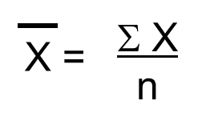
- What is the mean of your distribution? Show your calculations.

Measures of Variability

Watch the following video on measures of variability (Begin watching at 4:08):
https://youtu.be/mk8tOD0t8M0?t=237

- How is a range calculated?

- What is the range of your distribution? ____

- Here is the formula for population standard deviation:
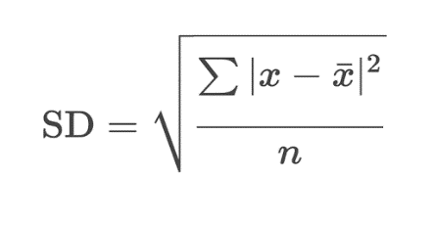
Note: The video above uses sample standard deviation formula.
- What is the standard deviation for your data set?

- What does the standard deviation tell you?

