ATTENTION STUDENT: If you are found to have plagiarized any part of your PsychSim assignment, you will receive a 0 for the assignment and may be formally reported to KPU. If you wish to quote the source provided or any other webpage, you MUST cite the source using APA formatting. To avoid plagiarism, write all answers in your own words.

For more information on plagiarism and cheating, please visit https://libguides.kpu.ca/academicintegrity/plagiarism to study the videos and tutorials available.
​
KPU's policy on academic integrity is found at https://www.kpu.ca/student-rights-responsibilities/academic-integrity

Name this file using the following format:
LastnameFirstname_Section_AssignmentName
For example: SmithJohn_A54_AuditorySystem

PsychSim Online: Operant Conditioning
Name: _______________________ Student ID: _________________
Course/Section: _______________ Instructor: __________________

Watch the following videos to answer the questions: https://www.youtube.com/watch?v=H6LEcM0E0io
https://www.youtube.com/watch?v=6Ofbt16AJgg

Identify if the following is part of classical conditioning or operant conditioning
- Associating a behaviour with a reward or punishment: ___________
- Pairing stimulus with a response: ___________
- Unconscious learning: ___________
- Conscious learning: ___________

Fill in the following table with the components of operant conditioning (positive reinforcement, negative reinforcement, positive punishment, or negative punishment).
 | Adding a Stimulus | Removing a Stimulus
Increase likelihood of future behaviour
Decrease likelihood of future behaviour

Fill in the following table with the components of operant conditioning (positive reinforcement, negative reinforcement, positive punishment, or negative punishment), and then identify the stimulus and the desired/undesired behaviour from each example.
Example | Component | Stimulus | Desired/Undesired Behaviour
A teacher reduces the amount of homework because the class accomplished a lot that week.
Alex gives their friend a gift for helping them move to a new house.
A father removes video game privileges for one night because Mary did not do her chores.
A student is very disruptive and disrespectful to students in their class at KPU, so the instructor asks them to leave the classroom.
A mother thanks her child for doing the dishes.
John was given a 5-minute time out for lying to his sister.
An employee is caught stealing from their work and is fired for doing so.
To get rid of a bad smell from his kitchen, Kevin took the garbage outside.

For each example, provide the schedule of reinforcement (Fixed ratio, Variable ratio, Fixed interval, or Variable interval) and drag the correct graph into the table.
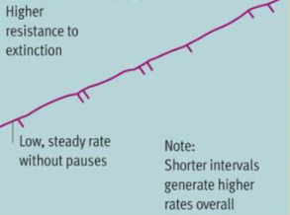
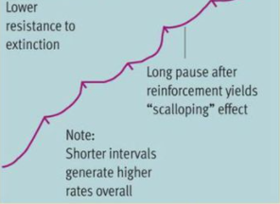
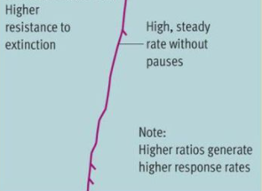
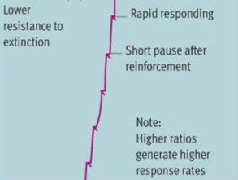

Example | Reinforcement Schedule | Graph
A young child is praised for cleaning up every time they pick up 5-7 items from the floor.
An employee is given a paycheck every two weeks for showing up to work.
Every time a student does 3 bonus questions, they get 1% bonus grades.
Every 3-5 minutes, a food pellet is given to a rat if they perform a desired behaviour.

In any of the reinforcement schedules, if the reward stops being delivered the behaviour will stop occurring. This is called extinction. Your textbook refers to extinction in more detail.
Which reinforcement schedule is the most resistant to extinction?

