KSC Junior Design 2024
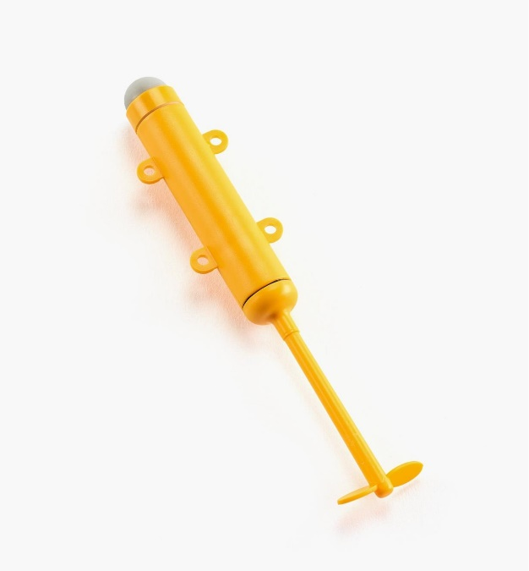
Design: Students will build a boat that uses a provided propeller to race down an artificial pond against another team in a double-elimination tournament. Winners of each group will compete at the end of the day in a championship tournament.

https://www.leevalley.com/en-ca/shop/home/toys-and-games/toys/110489-make-your-own-motor-boat?item=45K1204

The Boat: must always fit into a 50 cm sizing cube during the event. The hull of the boat must be student-made using common hobby materials such as paper, metal foil, thin plastic, or wood. It is not acceptable to use a ready-made toy or a kit for this challenge. A 3-D printed hull is allowed provided teams provide photos to verify that they did the work themselves. The judges reserve the right to veto any design that they deem counter to the spirit of the rules. Check in advance if you are unsure. The boat is to be powered by a small battery powered propeller. To ensure a level playing field, each team will be provided with a single brand-new propeller at the time of the event. The propeller is about 15 cm long in total and the cylindrical part has a radius of about 1 cm. Only this propeller can be used to move the boat. After receiving the propeller, the teams will have 5 minutes to attach it to their hull prior to the race.
The Course: is in an artificial pond 14 ft long by 4 ft wide by 4 in deep (measurements accurate to within +/- 1 inch). Timing beams will be placed 3 ft from each end to make a 8 ft long course (measurements accurate to within +/- 1 inch). The boat must have a flag (suggestion: at least 5cm by 5 cm - stiff opaque plastic) that extends above the water to break the timing laser beams (which are located 10 +/- 2 cm above the water's surface). *The flag should be at the front of the boat.*
The Race: At the start of the event, teams will be given one new boat propeller with fresh batteries. Team will have 5 minutes to attach this propeller to their boat. This propeller is to be the only source of power for the boat. The entire boat is to be released entirely behind the start line. It may not be touched after this and must travel the course "on its own". Boats are allowed to touch the side of the course but not the bottom. The score for this event will be based on the time to complete the course. Boats that do not complete the course will be given a certain minimum participation score.
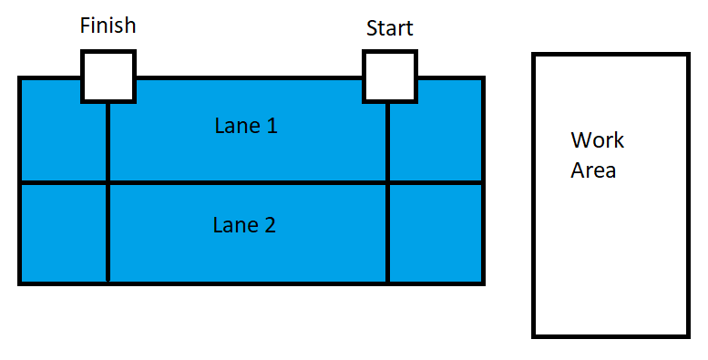

The Fine Print: The judges reserve the right to veto any design that they deem counter to the spirit of the rules and their decisions will be final. Please ask them in advance for clarification or adjudication to avoid disappointment on event day.

