AppsAnywhere: Accessing Software on a Personal Computer
Overview
To support our students, faculty, and staff working from home, the KPU IT Department offers the AppsAnywhere and Cloudpaging Solution. This software will allow Windows Based Devices to access KPU applications remotely; all you need is an Internet connection and the AppsAnywhere Client.
Mac computers only need to log into the AppsAnywhere Portal to run the software programs using Cloudpaging. No client installation is required because the software programs run in the cloud.
Note: Please SAVE your work frequently and make sure to CLOSE the application once finished.
Accessing Software on a personal Windows Computer
- Install the AppsAnywhere client and Cloudpaging Player. (You may skip this step if the software is already installed.)
- Open your preferred web browser and go to https://appsanywhere.kpu.ca/
- Enter your KPU Student ID and Password to login.

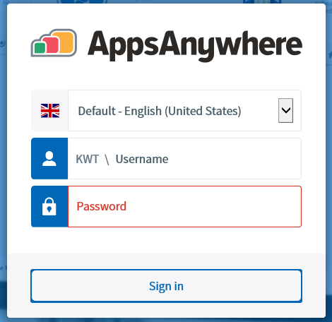
- Click It’s my first time using AppsAnywhere on this device. Let’s go.

- The AppsAnywhere client installation will download automatically. Once complete, click Run. Once the icon appears, click Done to complete the installation

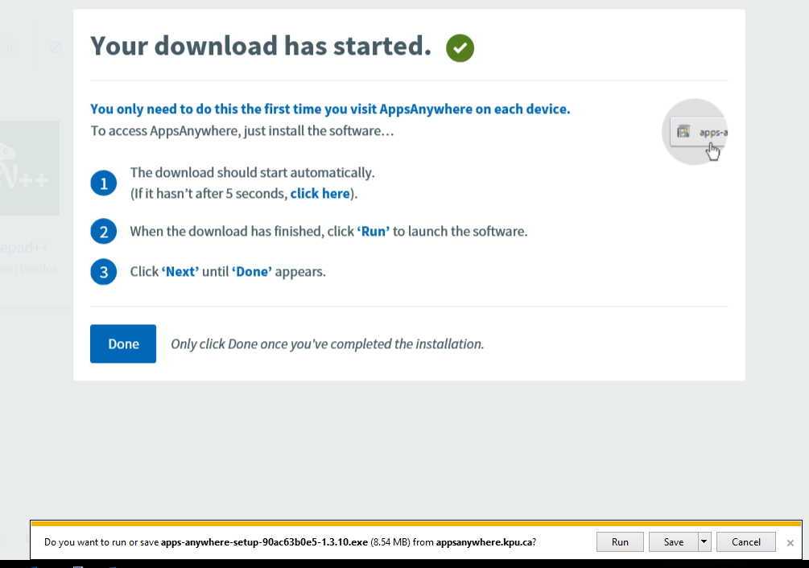
- The AppsAnywhere client install dialog box will appear. Click Next through the installation guide
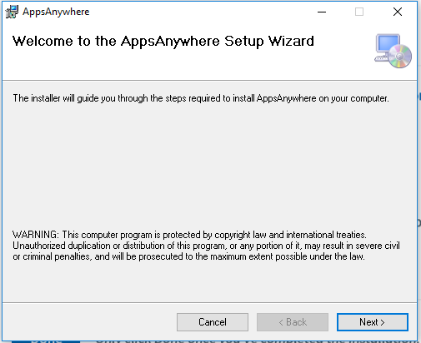

- Click Next
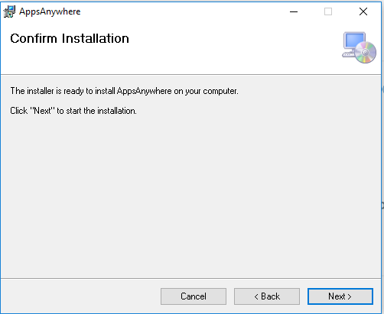

- Click Close
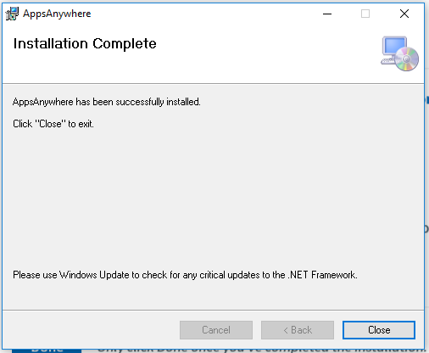

- The AppsAnywhere client install dialog box will appear. Click Next through the installation guide.

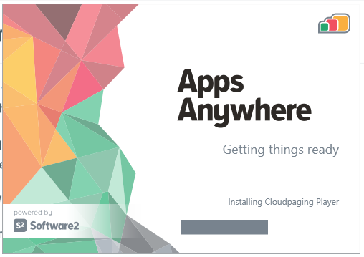
- Click Close
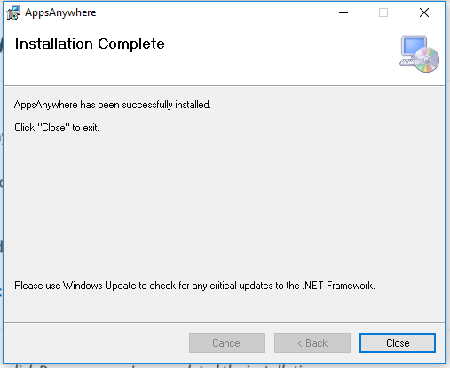
- Click Allow
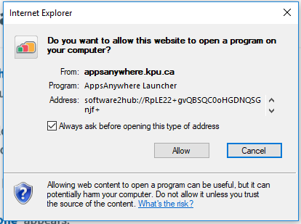

- Your browser may prompt you to open the launcher. If it does, check the box to Always open these types of links in the associated app and click Open AppsAnywhere Launcher
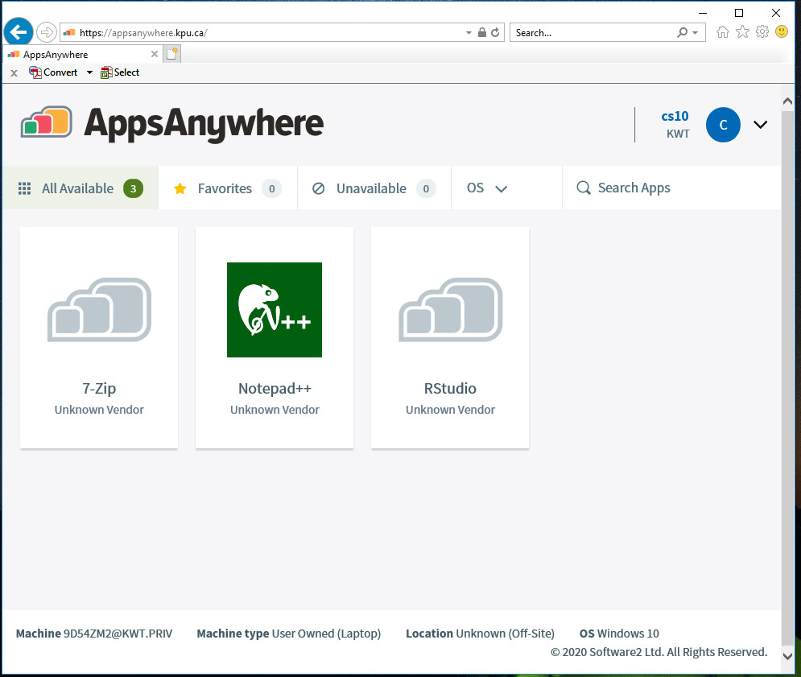

- Once the AppsAnywhere Launcher is installed you can hover over any application and click Launch to launch it.
- The first time you launch an application, it may be slow due to the installation process. After the initial launch, the application will load faster.
- The initial installation steps of AppsAnywhere client and the Cloudpaging player should only be necessary one time.

- Click Allow
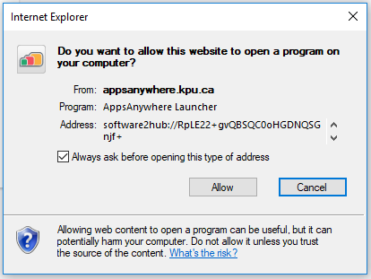

- The application will be downloaded, installed, and started from the Cloudpaging player. You can check the status of the application installation and launch by looking at the Cloudpaging Player.
  - If the Cloudpaging player is not installed, it will download automatically the first time an application is launched from the portal.
- Once the application is installed, you should be able to launch the application from the Start Menu as long as you don’t remove the application from the Cloudpaging Player.
  - Note that the application will not appear in the Add/Remove Programs list even though it does appear on the Start Menu.
- Click GREEN Launch Button
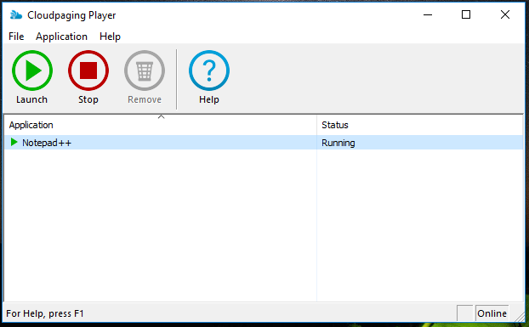

- Application Launched
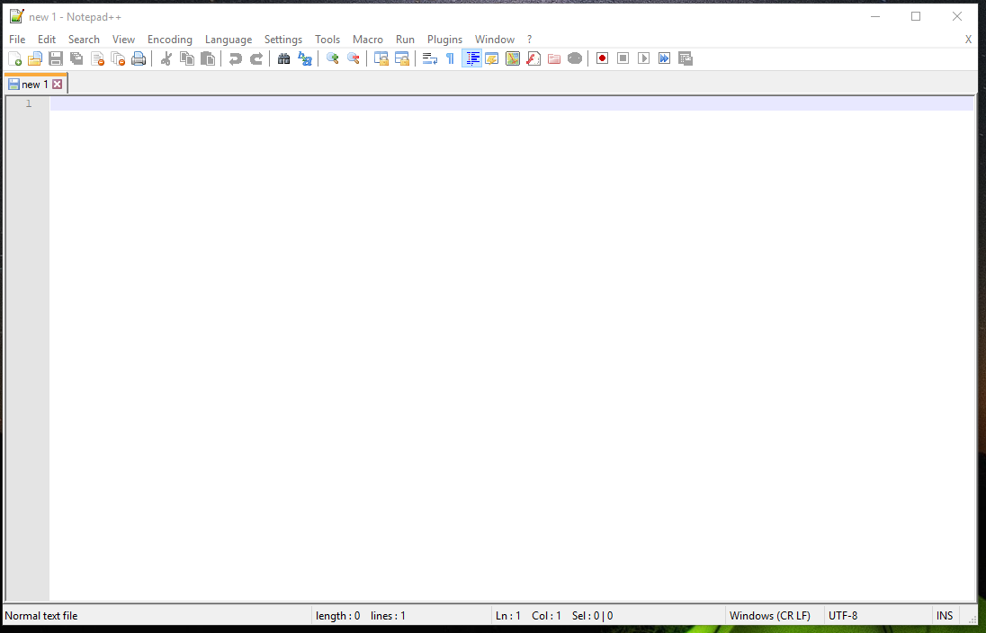

- Click Exit to close application
