Level One
Writing Tutor Training Workbook
The Learning Centres at
Kwantlen Polytechnic University
September 2022
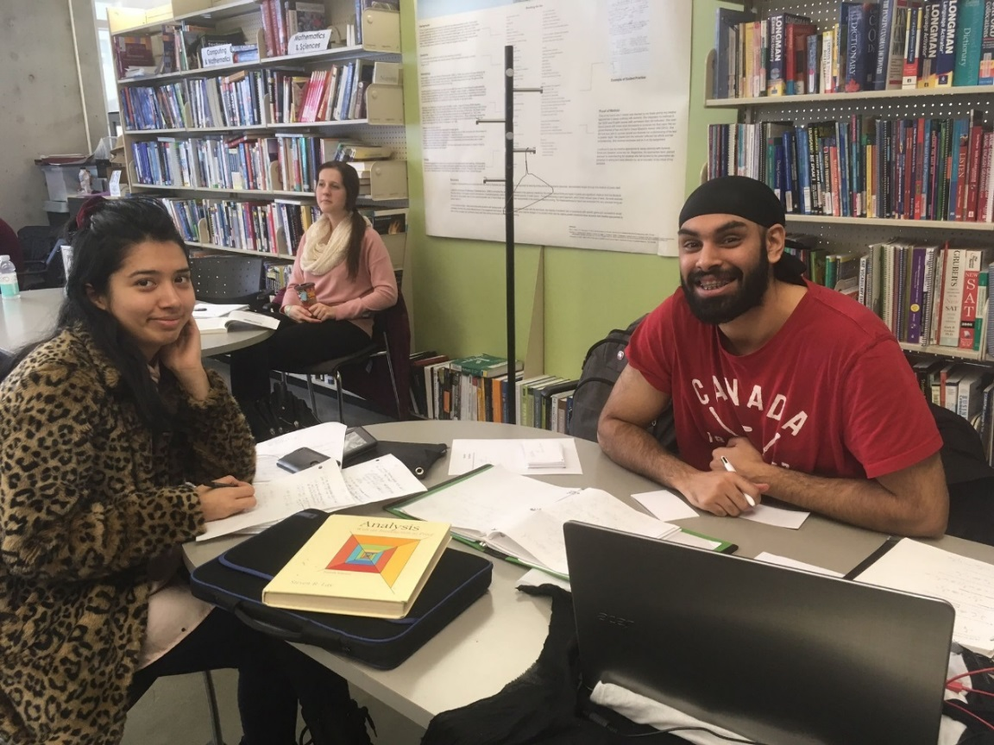



KPU Writing Tutor Training – Level One
List matches topic and time requirements for CRLA and is aligned with KPU TLC practices.

Level One Workbook for 1 Day Writing Training (6 hours)
Contents
Foreword 1
Outcomes 1
Reflect on the Process of Tutoring Writing 2
Starting Writing Tutor Training 2
Provide a Reader’s Response 4
Use Active Listening 4
Define Tutor Boundaries 5
Roles 5
Identify the General Stages of the Writing Process 7
The Writing Process 7
Identify Ways That You Approach Writing 8
Identify Strategies to Help Tutees with Their Writing 9
Mind Mapping 9
Concept Maps 10
Templates 12
Nutshelling 15
Minimal Marking 16
Identify Priority Issues of Higher and Lower Order Concerns 18
Higher Order Concerns (HOCs) 18
Lower Order Concerns (LOCs) 19
Identify Marking Symbols and Abbreviations 21
Practice Giving Writing Responses 22
Develop Session Plans for Writing Tutoring 27
Session Planning Template 27
Conduct Writing Tutoring Session Using the Tutoring Cycle 29
Refer Tutees to Suitable Writing Resources 36
Interact with Tutees as a Writing Tutor 38
Tutor Fundamental Outcomes 38

Peer Tutoring Writing Workbook Level I by http://www.kpu.ca/learningcentres
is licensed under a
Creative Commons Attribution-NonCommercial-ShareAlike 4.0 International License.
Written and compiled by Alice Macpherson, PhD, 2016, 2019.
With revisions by Christina Page, Marti Alger, Kim Tomiak, 2022, and Lyn Benn.
Reviewed by faculty and staff members of
The Learning Centres at Kwantlen Polytechnic University, Surrey, BC, Canada
The Learning Centres at Kwantlen Polytechnic University respectfully acknowledge the Kwantlen, Musqueam, Katzie, Semiahmoo, Tsawwassen, Qayqayt, and Kwikwetlem peoples on whose unceded traditional and ancestral lands we are privileged to work and learn.

Foreword
This Workbook and Training Session, coupled with online modules and coaching from your Writing Mentor will bring you to the standard needed for Level One Writing Tutor certification.

Tutor Name | Date of Tutor Training
My Writing Tutor Trainer(s) | Contact Info
Writing Tutoring Subject Area | Tutoring Since Date

Outcomes
As a writing tutor you will be focusing on process – rather than product – to help your tutees become better writers. This training will help you to use specific strategies at the different stages of the writing process and to analyze writing to select the most appropriate area(s) to work on. You will be identifying ways that writing tutoring requires expertise and is built on scholarship. This is a chance to begin your professional development as a writing tutor as well as continuously improve your grammar and mechanics of writing.

Reflect on the Process of Tutoring Writing
By this point you have completed the Fundamental Peer Tutor training and completed the following objectives:
- Identify the Scope of Peer Tutoring in the Learning Centres
- Define Peer Tutoring Roles and Responsibilities
- Behave Ethically when Tutoring
- Analyze Tutoring Situations Where Ethical Choices Are Made
- Plan Tutor Sessions
- Utilize the Tutoring Cycle
- Communicate Effectively as a Tutor
- Use Critical Questioning
- Define Bloom’s Taxonomy
- Use Referrals (When You Need Assistance)
- Identify When to Stop the Tutoring Process
You will also be starting the work on the Integration Exercises in Moodle that include:
- Follow Learning Centres Procedures (includes beginning Tutor Certification process)
- Complete LASSI (study skills for success) and Debrief with a Learning Strategist
- Create Reflective Journal Entries on Tutoring Practices
- Integrate Adult Learning Basics into Tutoring
- Discuss Issues of Copyright
- Practice Academic Integrity
- Set a Professional and Welcoming Environment
- Shadow Tutoring Sessions
- Plan Sessions and Document the Tutor Processes
- Self Evaluate, Receive Tutee and Other Feedback

Starting Writing Tutor Training
Start the Writing Tutor training by introducing yourself, giving your name, major area of specialization, area of academic interest and possible strengths as a Writing Tutor.
As we get to know each other a bit, we will also become aware of the diversity of backgrounds that we bring and the initial concepts that we have about our tutoring practices.

Activity: Simulation of Tutoring
Form pairs. One person will be the tutee; the other will be the writing tutor.
Tutee: You are in first-year and have received your first university writing assignment, due two days from now. The instructor has asked the class to produce a 500-word paper to get an idea of writing abilities. You have come for assistance because you are uncertain whether your draft is university-level writing. You have booked a 30-minute appointment with a Writing Tutor.
Use the untitled composition by “Jack” or “Jacqueline” (adapted from Muriel Harris' Teaching One-to-One).
Tutor: You will help your tutee with their writing process.
We will stop the session at the 10-minute mark. Then we will switch roles and repeat the simulation.

Untitled
“Jack” or “Jacqueline”
The activity that I find myself doing to relax & unwind is a slow walk. I usually perform this action when I am upset, either at myself or someone I am acquainted with. I sometimes walk for a couple of hours, just thinking about my problems, and alot of the time I do find myself having a pretty good conversation with myself. When I'm walking I notice alot of things about people. I see flowers, trees and alot of other natural sights. Such as the wildlife. I think my biggest focusing point when I'm walking and thinking it the sky. It is so beautiful no matter what sate it is in. On a bright sunny day it is a fascinating light blue, but on a windy, stormy day it is a very fluffy, gray, low hanging bunch of billows. As I walk I feel the wind zip through me, the rough pavement beneath my fee, and the unraveled strings in my pockets. I hear an occasional sigh from deep within myself as my voice echoes off the seasonal air and reflects my verbal thoughts back to me. My sense of smell is usually focused on the clean freshness of the country air, but it is tampered with sometimes by the sweet smell of a patch of wild flowers. My walks really make me understand my self and most of the time I feel relieved upon returning home again.

Activity: Discussion
What surprised you in this simulation?

What would you now like to learn and discuss about Writing Tutoring?

Provide a Reader’s Response
As a tutor you are reading the writing as presented and providing a reader’s response to the materials. This means that you are reading to appreciate what has been written and your comments will reflect what you understand the writer to be saying. When you are confused, you can say so and ask for clarification, e.g. “I am not sure what you are trying to say here.”
When you respond as a reader, you are helping to facilitate the writer’s thought processes and encourage them to further consider, explore, and clarify their ideas and writing.

Use Active Listening
Your good communication and active listening Fundamental Skills (Communicate Effectively as a Tutor) are the basis of your interaction with Tutees. You can both give a reader’s response and ask for clarification as you work with the tutee writer.
“This is what I get from this sentence. Is that what you mean?” “Can you tell me in your own words what you want to write?”
Listen carefully to their words and jot down some of the ideas that they say so you can explore them further with the tutee who is seeking help. These skills include:
- Reacting as a Reader
- Requesting Information
- Requesting Clarification
- Developing Critical Awareness
- Refocusing
- Prompting
Read: The Bedford Guide for Writing Tutors, Chapter 2, pp. 19-23.

Activity: Provide a Reader’s Response
Using the first short paper, you and your partner will brainstorm ways that you can provide a reader’s response to the writer. Write out your best ideas here so you can refer to them later.

Define Tutor Boundaries
As noted in the Fundamental tutor training, a Tutor is not an Instructor. The tutor’s role is to facilitate the writer considering and elaborating on their thoughts and ideas.

We Do:
- Discuss assignments
- Help tutees analyze marked assignments
- Give short explanations on elements of grammar and structure
- Help tutees locate resources
- Point tutees in productive directions
We Do Not:
- Do tutee assignments
- Guess what mark that the tutee might receive on an assignment
- Give tutees the answers
- Locate tutee resources for them
- Proofread or edit

You need to be mindful of the boundaries zone between you and your tutees so that you do not breach the tutor ethics that are fundamental to being a good tutor. It can also be difficult to draw the line when your tutees and friends find out that you are tutoring writing and ask for just a little more assistance. Remember that you need to have time for your own studies, family, and recreation. Avoid overloading yourself!

Roles
We find ourselves taking on many roles with the title of Tutor:
- Ally
- Coach
- Commentator
- Collaborator
- Writing “Expert”
- Learner
- “Counselor”
Using the text readings in The Bedford Guide for Writing Tutors, Chapter 1, pp. 4-8 complete the following activity as a group.

Activity: What can I do?
As you discuss this area, write down examples of how you might behave with a tutee in the following roles:

Ally

Coach

Commentator

Collaborator

Writing “Expert”

Learner

“Counselor”

Identify the General Stages of the Writing Process

The Writing Process
Although there is no single way to write, it helps to keep in mind that writing is a process that involves a number of stages and is iterative. To produce the best work, the writer needs to concentrate on one stage at a time.
One resource may identify three process areas for consideration:
- Prewriting
- Drafting
- Revising and Editing

Other resources may outline the process in different ways. This includes the KPU Writing Process model retrieved from: https://community.moodle.kpu.ca/pluginfile.php/4456/mod_resource/content/1/LC%20-%20The%20Writing%20Process%20-%20Writing%20Essays%20in%20General%20-%20Not%20about%20Texts%20-%202015.pdf
KPU English Writing Process model:
Part One – Getting Started
- Don't procrastinate.
- Sub-divide the task.
- Consider your purpose.
- Consider your audience.
- Narrow your topic.
- Leave a paper trail.
Part Two – Organizing the Material
- Group your ideas.
- Develop a preliminary thesis statement or topic sentence.
- Create a rough outline.
- Write a rough draft.
Part Three – Revising and Polishing the Draft
- Revise for structure and content.
- Edit for grammar and diction.
- Don't forget to double-check the submission requirements.

Activity: Stages of the Writing Process
Compare this writing process (prewriting, drafting, revising and editing) to the KPU English Writing Process model. Be prepared to share your findings.

What do these models have in common and what is different?

Identify Ways That You Approach Writing
Reflect on your personal approach of how you adapt the common process to do your own writing by sharing your writing process and listen to other people describe their writing process.

Activity: Writing Process
What is your personal writing process for an academic essay? Consider the following:
- Do you:
  - Spend days worrying about it?
  - Immediately jot down ideas and then start playing with them?
  - Think for a long time and then produce a first draft at one sitting?
- How do you go about actually producing a draft? Do you:
  - Carefully assemble specific materials – like pencils and pad of paper?
  - Get into comfortable clothes?
  - Sit at the computer?
  - Create an introduction that “will suffice” and then rework the introduction later?
  - Write, pace the floor a bit, then write again, pace again etc.?
- Do you write with the advice of a particular person – maybe a former teacher – echoing in your head as you compose?
- When do you begin to consciously consider your audience?
  - From the outset?
  - When you outline?
  - As you revise your draft?
- Do you seek the advice of others as you write? Do you read or show people drafts or parts of drafts? What kinds of feedback do you look for? When others give suggestions, how do you factor them in?
- How do you feel when you have completed a paper? Are you simply glad it is done? Are you convinced that one more pass would produce a better paper?
Capture your process on sticky notes and cluster them into your perceived steps of the writing process. Share this with the other participants on a large board.
In what ways do these fit with the other writing processes that you have looked at?

Summary of Writing Approaches
You can see that there is no single way to write but there are steps and an observable flow to the process. Shifting the focus to the writing process has been one of two major changes in composition in the last quarter century. If we compare sports training and writing you can see a clear importance of process. As Tutors, we intercede in this process. We focus on a model of adult learning that is facilitated and constructed. We understand the writing process as a method of thinking, of cognitive problem-solving occurring in recursive phases. We guide tutees with strategies that they can use for each phase. This promotes better learning for the tutee.

Identify Strategies to Help Tutees with Their Writing
We will practice a few of the many strategies that can be used to assist the writing process at various stages. These form a core of our tutoring and will be the foundations to add others in the future.

Mind Mapping
Clustering ideas, (also called mind mapping by Tony Buzan, 1968), is a way of collecting ideas around a particular topic and defines connections. Clustering may be defined as a “nonlinear brain storming process akin to free association” (Rico, 1983, p.28). Brainstorming was defined by Alex Osborn in 1941 as a creativity technique by which efforts are made to gather a list of ideas around a central topic. The rules are: no criticism of ideas, go for large quantities of ideas, build on ideas, and encourage wild and exaggerated ideas. When these rules are followed, a lot more ideas are created and that a greater quantity of original ideas gives rise to a greater quantity of useful ideas. Particularly at the beginning of the writing process, you may explore a topic and generate content by creating a clustering diagram.

Examples of Clustering and Mind Mapping
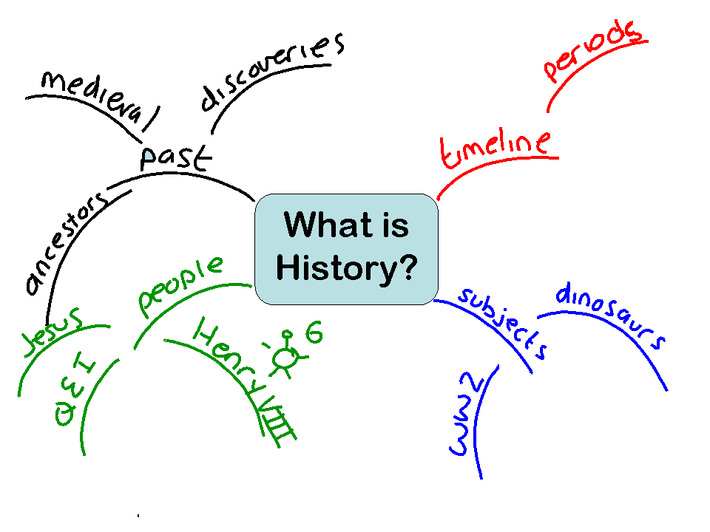
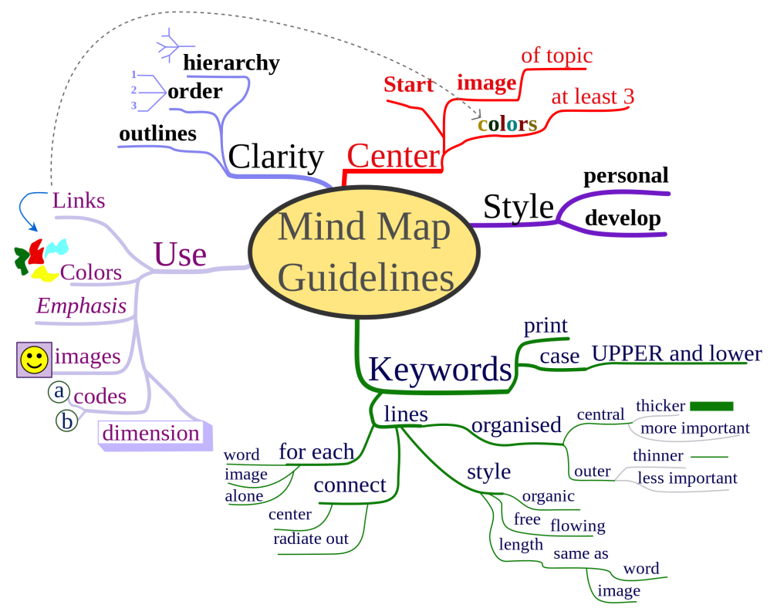

Concept Maps
Clustering is a good way to start the process of inventing new writing but may need elaboration to be useful to the process of academic writing. Concept Mapping is the process of creating a detailed visual representation of your knowledge. This type of system predates the development of alphabets and the written word and is a deeply embedded way that humans organize and communicate information. It is a graphic organizer that gives a visual representation of concepts and the relationships between and among them and then identifies how they relate to each other.
This technique uses a connectionist system approach that connects various parts of your mind and initiates a process known as Distributed Associative Memory (McClelland & Rumelhart, 1985), which allows your mind to connect to deeper and deeper levels of knowledge and can trigger insights and original ideas.

Example of Concept Mapping
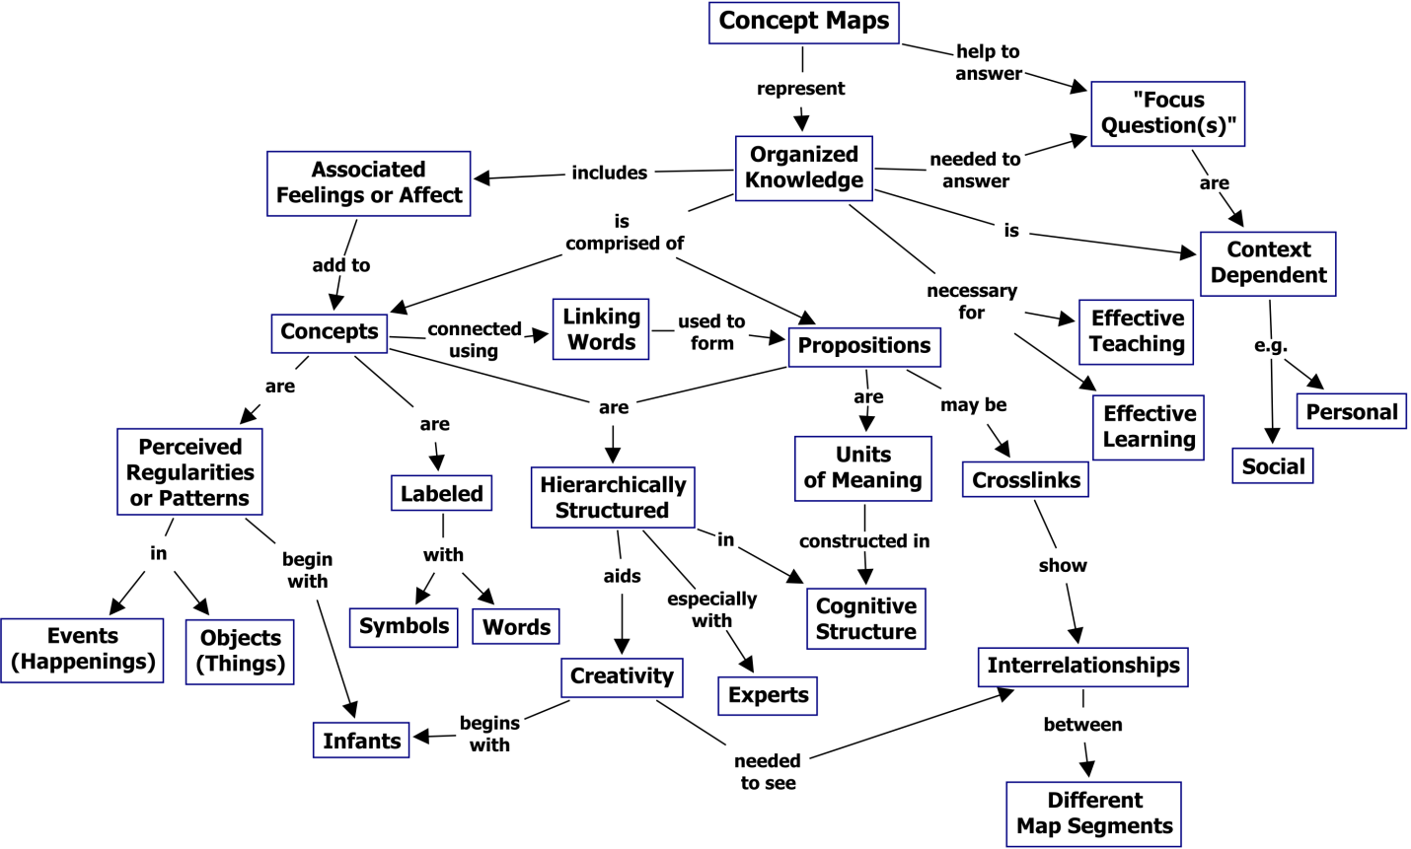

You start with concepts or ideas that are placed in boxes (or circles, or clouds) and then connected with lines and arrows. This is the basic clustering or mind mapping process. Along the connecting lines you will write verb phrases such as: “gives rise to”, “results in”, “is required by”, or “contributes to” (Novak & Cañas, 2006, p.3) that indicate relationships and movement.
This technique for visualizing relationships among different ideas is called “Concept Mapping” and allows you to continue to elaborate on the basic ideas that you have generated. There is a more detailed Learning Aid on this method here: http://www.kpu.ca/sites/default/files/Learning%20Centres/Reflect_ConceptMap_LA.pdf

Activity: Mapping an Assignment
- Turn to a fresh page. For whatever you want to explore, write the key word or phrase in the middle of your page and circle it. For instance, if your assignment were to “Discuss a Strong Emotion,” your nucleus might be “fear of flying,” “joy,” or “anger.” This first circle is the nucleus of your cluster.
- Thinking of the keyword or nucleus, write whatever words or phrases come to mind. These words or phrases will radiate outward from the nucleus word. Each one is a train of thought that forms an arm or section of the map. Connect each word or phrase with related words or lines, adding arrows to indicate direction, if you wish. Work quickly. The map doesn't have to be neat or follow any particular shape.
- Continue jotting down ideas for a minute or two. If nothing occurs to you, doodle by putting arrows on your existing cluster. This doodling keeps your hand moving and may allow associations to come more freely – just like getting your best ideas when washing the dishes, swimming laps, or going for a walk. Look at each arm or section of your cluster: Can you add anything else?
- When you seem to have run out of ideas, sit back, look at your map, and decide what to keep and what to cut. No one can tell you how to do this. Sometimes select only what applies directly to the assignment. Other times look for the area of most connections, and keep that material. Maybe go with whatever interests you. Because the grouping results from a brainstorm, you will almost certainly discard some of the cluster. The next step is to organize what you have kept.
- Move to Concept Mapping and begin to add verb phrases between your ideas, starting with the nucleus keyword. This will help you form sentences and create paragraphs that can become the basis for your paper.

Activity: Application in Writing Tutoring
How might you use a mapping / clustering strategy with a tutee to help them get started?

How might concept mapping help your tutee elaborate on their basic ideas?

Templates
Templates are models that afford a structure to get you started on a writing project, while giving you the ability to add needed elements as you, the writer, see fit.
Templates are a step beyond the basic essay outline format of “introduction; thesis; three-points; conclusions” style that may be the basis of essay writing that tutees are already familiar with.
Major strengths of using a model, which is also evident in the structure of science or business reports, include the following:
- forces writers to consider issues they may normally ignore,
- encourages the writer to break the topic into manageable chunks, and
- helps the writer establish a basic, solid organization.
Consequently, the template is often useful for first-year students, divergent thinkers who cannot get a handle on their topic, writers who have never learned how to write an essay, and students who are used to writing in one genre (frequently narrative) and any others having trouble getting started.

Activity: Using Templates
Templates are useful ways to codify the writing process into manageable chunks. This template should be thought of as generic since each discipline has its own way of writing that you should become aware of and follow in those classes. Assignment directions will often outline the basic process that you should be following.
How might you use the following template with a tutee to help them get started on a writing assignment?

1. Topic (State in 10 words or less.)

2. Specific topic (Narrow the topic - state in 5 words or less.)

3. List three or four main areas of interest or important concepts related to the narrowed topic.
A._______________________________________________________________________________
B. ______________________________________________________________________________
C. ______________________________________________________________________________
D._______________________________________________________________________________

4. Restate 3A in a sentence.

List 4 facts or concepts of interest related to 3A.
A._______________________________________________________________________________
B. ______________________________________________________________________________
C. ______________________________________________________________________________
D._______________________________________________________________________________
Why is this important? ______________________________________________________________

Repeat this process for statements 3B, 3C and 3D.
Restate 3B in a sentence.

List 4 facts or concepts of interest related to 3B.
A._______________________________________________________________________________
B. ______________________________________________________________________________
C. ______________________________________________________________________________
D._______________________________________________________________________________
Why is this important? ______________________________________________________________

Restate 3C in a sentence.

List 4 facts or concepts of interest related to 3C.
A._______________________________________________________________________________
B. ______________________________________________________________________________
C. ______________________________________________________________________________
D._______________________________________________________________________________
Why is this important? ______________________________________________________________

Restate 3D in a sentence.

List 4 facts or concepts of interest related to 3D.
A._______________________________________________________________________________
B. ______________________________________________________________________________
C. ______________________________________________________________________________
D._______________________________________________________________________________
Why is this important? ______________________________________________________________

5. Compile your conclusion from the key points you have made throughout the essay and your ‘Importance’ statements.
3A & Importance?

3B & Importance?

3C & Importance?

3D & Importance?

6. List four major resources you might utilize to research your topic.
1._______________________________________________________________________________
2. ______________________________________________________________________________
3. ______________________________________________________________________________
4._______________________________________________________________________________

7. Write a simple yet all-inclusive thesis statement that will allow the reader to know immediately and exactly what he or she will learn from your paper.

8. Write the introductory paragraph of your paper. Underline your thesis statement. Create your introduction on a word processor. Remember to spell check and grammar check.

Notes and Questions:

Nutshelling
This could also be thought of as a form of summarizing and is sometimes called the “Elevator Pitch” (what you would say on a short elevator ride to convey an idea). A summary is always a shorter form of the larger information where only the main points are included and thoughts are condensed without losing the essence of the idea.

Examples of Phrasing
“Can you put in a nutshell – two or three sentences – what you're trying to say in this composition?”
OR
“Can you summarize – two or three sentences – your main idea or argument in this essay? Don't try to say one word-perfect thesis statement, but try to convey the essence of what you're trying to say using no more than three sentences. You say it, and I'll write it down for you.”
OR
“Sometimes when you're revising your essay, it's a good idea to try a technique called nutshelling. A short time after someone reads an essay, the person only remembers the gist or the key point or one striking example. So it's a good idea to be very clear about the message you're trying to convey, and put that message where it is most likely to be remembered: the introduction and the conclusion. So try nutshelling, or summarizing in two to three sentences, the main thing you want your reader to know and remember.”
OR
“Imaging that you are headed for a class and I'm dashing off somewhere when we meet. I say, I hear that you're writing a paper on something very interesting. Neither of us has time to talk now. Can you tell me in thirty seconds – two or three sentences – what you say in your paper?”

Activity: Create Phrases to Invite Nutshelling
Write out several phrases that you would use:
Try them out with a partner.

Notes and Questions:

Minimal Marking
Many students seek support from a writing tutor to identify and correct errors in their writing. How do you address this concern without falling into the proofreading trap, creating dependence on your support? Minimal marking is a strategy for helping tutees learn to more accurately identify and correct their own writing errors. It is especially useful for patterns of grammar errors that follow a predictable pattern, but can also be used for word choice errors.
What is minimal marking?
Minimal marking is a technique of making tutees aware of errors in their writing by showing in the margin that errors exist in that section of writing, without telling the tutee exactly where.
Procedures for minimal marking
- Select the error that you are focusing on in the session. Minimal marking is effective when used to address only one type of error at a time (e.g. subject-verb agreement, article use, fragments). You may wish to use an error log with tutees to collaboratively identify the pattern of error that would be most productive to address in the session.
- With the tutee, name the error pattern you will address. Use questions to explore the tutee’s knowledge of the issue (e.g. How do you decide whether to use the singular or plural form of the verb?). If the tutee is unclear about the concept, step back and take a few minutes to explain, and perhaps assign some exercises to the tutee. When the tutee understands the concept, move on to the next step.
- Ask the tutee to identify the errors in a paragraph or short section of text (e.g. There are several subject-verb agreement errors in this paragraph? Can you find and edit them?). If the tutee is not able to correct their error, continue through the process.
- Ask the tutee for permission to make checkmarks on their paper. Remember that the tutee should “hold the pen” and make any changes to their writing themselves.
- Place a checkmark beside each line where the error occurs (there may be more than one checkmark beside some lines). Explain to the tutee that each checkmark represents one error (There is one subject-verb agreement error everywhere you see a checkmark. Can you find and correct them?)
- Provide positive feedback to the student as they correct their errors, and encourage them as you observe their growth in self-editing. If the student missed some errors, help them to make connections with the errors that they did successful fix in order to correct the remaining problems.

The minimal marking strategy can be an excellent way to help tutees gain confidence in their ability to use self-editing skills. After using the minimal marking strategy, you may wish to share an additional self-editing technique with the student, or encourage them to follow up with another session to continue refining their self-editing skills.
Additional self-editing techniques such as using error logs, developing a personalized editing resource, and using dictionaries to improve your writing are further explained in An Editing Guide for ESL Students: https://community.moodle.kpu.ca/pluginfile.php/4446/mod_resource/content/1/LC%20-%20Guide%20to%20ESL%20Editing%20-%202015.pdf

Activity: Use Minimal Marking with Tutees
Use Minimal Marking in the Untitled paper below to practice making tutees aware of errors in their writing.

Untitled
“Jack” or “Jacqueline”
The activity that I find myself doing to relax & unwind is a slow walk. I usually perform this action when I am upset, either at myself or someone I am acquainted with. I sometimes walk for a couple of hours, just thinking about my problems, and alot of the time I do find myself having a pretty good conversation with myself. When I'm walking I notice alot of things about people. I see flowers, trees and alot of other natural sights. Such as the wildlife. I think my biggest focusing point when I'm walking and thinking it the sky. It is so beautiful no matter what sate it is in. On a bright sunny day it is a fascinating light blue, but on a windy, stormy day it is a very fluffy, gray, low hanging bunch of billows. As I walk I feel the wind zip through me, the rough pavement beneath my fee, and the unraveled strings in my pockets. I hear an occasional sigh from deep within myself as my voice echoes off the seasonal air and reflects my verbal thoughts back to me. My sense of smell is usually focused on the clean freshness of the country air, but it is tampered with sometimes by the sweet smell of a patch of wild flowers. My walks really make me understand my self and most of the time I feel relieved upon returning home again.

Notes and Questions:

Identify Priority Issues of Higher and Lower Order Concerns
Identifying and prioritizing a limited number of Higher Order Concerns (HOCs) and Lower Order Concerns (LOCs) is a critical part of helping tutees with their writing.

Higher Order Concerns (HOCs)
The most important parts of an academic paper, called the Higher Order Concerns, are the big picture elements. The following Higher Order Concerns need to be addressed before Lower Order Concerns.
Logic/Content
- Does the submission address the assignment as described by the student?

Thesis
- Is there a clear and well-focused controlling idea expressed near the beginning of the submission?
- Note: not all assignments necessarily require a thesis statement.
Depending on genre and the purpose of the assignment, the expression of a controlling idea may vary.

Structure/Organization
- Does the structure of the submission fit with the assignment as described by the student?
- Are ideas organized to support the stated thesis?

Introduction
- Does the introduction clearly introduce the topic and express a controlling idea as appropriate to the assignment?
- Do the ideas expressed in the introduction fit with the material presented in the body of the submission?

Conclusion
- Is the conclusion appropriate for the assignment?
- Does the conclusion only summarize material that has already been presented in the body of the submission?

Paragraph Structure
- Is there an appropriate amount of material in each paragraph and section to clearly express one idea?
- Are there topic sentences?
- Do paragraphs relate to the stated thesis?

Use of Evidence
- Is material relevant to the submission?
- Where appropriate to the assignment, has evidence been used to support the student’s claims?
- Is evidence properly attributed?
Integration of Sources
- Does the student frame evidence with his or her own words?

Explanation of Evidence
- Does the student adequately describe, explain, reflect on, or critique (as appropriate to the assignment) evidence?

Clarity and Flow (Coherence)
- Is the submission overly wordy?
- Is there reader resistance?

Transitions
- Are ideas linked through signpost words and phrases (for example, “however,” “although,” “on the other hand”)?
- Are there thematic connections between paragraphs and sections?

Problems with Lower Order Concerns (LOCs), such as sentence structure, can obscure the effectiveness of conveying Higher Order Concerns. This means that the writer may need to move back and forth between the HOCs and LOCs to produce the final essay.

Lower Order Concerns (LOCs)
After you have generally addressed the HOCs, you then turn your attention to the LOCs.
Style and Tone
- Are the level of formality and tone appropriate for the assignment?
- Is vocabulary or word choice appropriate?
- Is the passive voice used excessively or inappropriately?

Expression
- Grammar: are there repeated errors in noun or verb forms, tenses, agreement, or prepositions?
- Spelling: are there typos and/or “sound-alike” spelling errors?

Punctuation
- Are there repeated errors in the use of commas, semicolons, colons, or in end-punctuation?
- Are quotation marks used appropriately?

Sentence Structure
- Are there sentence fragments, mixed or illogical constructions, faulty parallelism, or faulty modifiers?
- Do sentences tend to sprawl or be too short/choppy?

Format
- Are in-text citations formatted correctly?
- Are references listed in alphabetical order?

Essay Checklist:
- Title reflected the thesis, not just the assignment topic.
- Introduction had an opening strategy.
- Gave an introduction to the broad topic.
- Had an introduction to the specific topic.
- Acknowledged the opposing arguments (if necessary).
- Stated thesis – argument about the topic.
- Provided a preview – how essay will be divided into paragraphs.
- Began each body paragraph with a topic sentence – link to the thesis is clear.
- Provided ample supporting details – each one directly supported the paragraph topic and provided clear connections between sentences.
- Ended each paragraph with a framing sentence.
- Conclusion briefly restated the thesis, using different wording and comments on the main arguments.
- Closing sentence sounds finished.
- Works Cited Page acknowledged any sources used in the essay.
For reference materials to help Tutees with HOCs and LOCs, see:
Basic Essay Structure
https://community.moodle.kpu.ca/pluginfile.php/4453/mod_resource/content/1/LC%20-%20Basic%20Essay%20Structure%20%20Essay%20Revision%20Checklist%20-%202015.pdf
Paragraph Structure
https://community.moodle.kpu.ca/pluginfile.php/4450/mod_resource/content/2/LC%20-%20General%20Paragraph%20Structure%20-%202015.pdf
Creating Transition between Sentences
https://community.moodle.kpu.ca/pluginfile.php/4454/mod_resource/content/1/LC%20-%20Providing%20Transition%20between%20Sentences%20-%202015.pdf
Formal Writing Guidelines
https://community.moodle.kpu.ca/pluginfile.php/4455/mod_resource/content/1/LC%20-%20FWG%20-%20Overview%20%20Guidelines%20-%202015.pdf
Sentence-Combining – Introduction
https://community.moodle.kpu.ca/pluginfile.php/4448/mod_resource/content/2/LC%20-%20Sentence-Combining%20-%20Overview%20%20Intro%20-%202015.pdf
Grammar Overview – All Rules
https://community.moodle.kpu.ca/pluginfile.php/4437/mod_resource/content/4/LC%20-%20Grammar%20Cheat%20Sheet%20-%202021.pdf

Activity: Analysis of First Simulation Paper
Apply the hierarchy of concerns to the paper used in the first simulation. What would you suggest that the writer work on first? Why?

Identify Marking Symbols and Abbreviations
The following editing abbreviations and symbols are from the KPU Virtual Writing Centre and are a representative sample of the types of marking used in English essays.
Links for the grammar explanations are also available at: https://community.moodle.kpu.ca/pluginfile.php/4449/mod_resource/content/2/Editing%20symbols%20June%202022.pdf

Symbol | Explanation | Symbol | Explanation
? | Unclear | rep | Unnecessary repetition
agr | Faulty agreement between subject and verb (s-v) pronoun and antecedent (p-a) person  tense | run-on | Run-on sentence (check punctuation; see fused sentences and comma splices)
awk | Awkward construction | s/pl | Singular and plural form  confused
coll | Colloquial idiom, slang | shift | Incorrect shift in tense,  person or voice
cs | Comma splice | sp | Incorrect spelling
dm | Dangling modifier | trans | Faulty or weak transitions  between points
frag | Sentence fragment | vt | Incorrect tense of verb
id | Flawed idiom (often misused prepositions) | wc | Error in word choice
mixed | Mixed sentence structure | wm | Word missing
mm | Misplaced modifier | ww | Wrong word
P | Incorrect punctuation  - Comma error  - Semi-colon or colon error |  | Omit
// | Parallelism |  | Insert material
passive | Passive voice |  | Close up space
ref | Faulty or unclear pronoun reference | ¶ | New paragraph needed
For help with idiom, verb tense, singular/plural errors, vocabulary, preposition and article use, visit the Learning Centre’s ESL webpage: https://www.kpu.ca/learningcentres/esl

Practice Giving Writing Responses

Activity: Practice Paper I
This is an example of a paper that has been marked by an instructor. The tutee is looking for some guidance on how to rewrite this paper. The first page is the Assignment as given by the Instructor. The four pages after this are the student’s returned paper.
How do you understand the assignment and what the instructor was after?
How do you understand what the instructor is trying to convey with their marking?
What would be your first (second, third) suggestions at what to tackle?
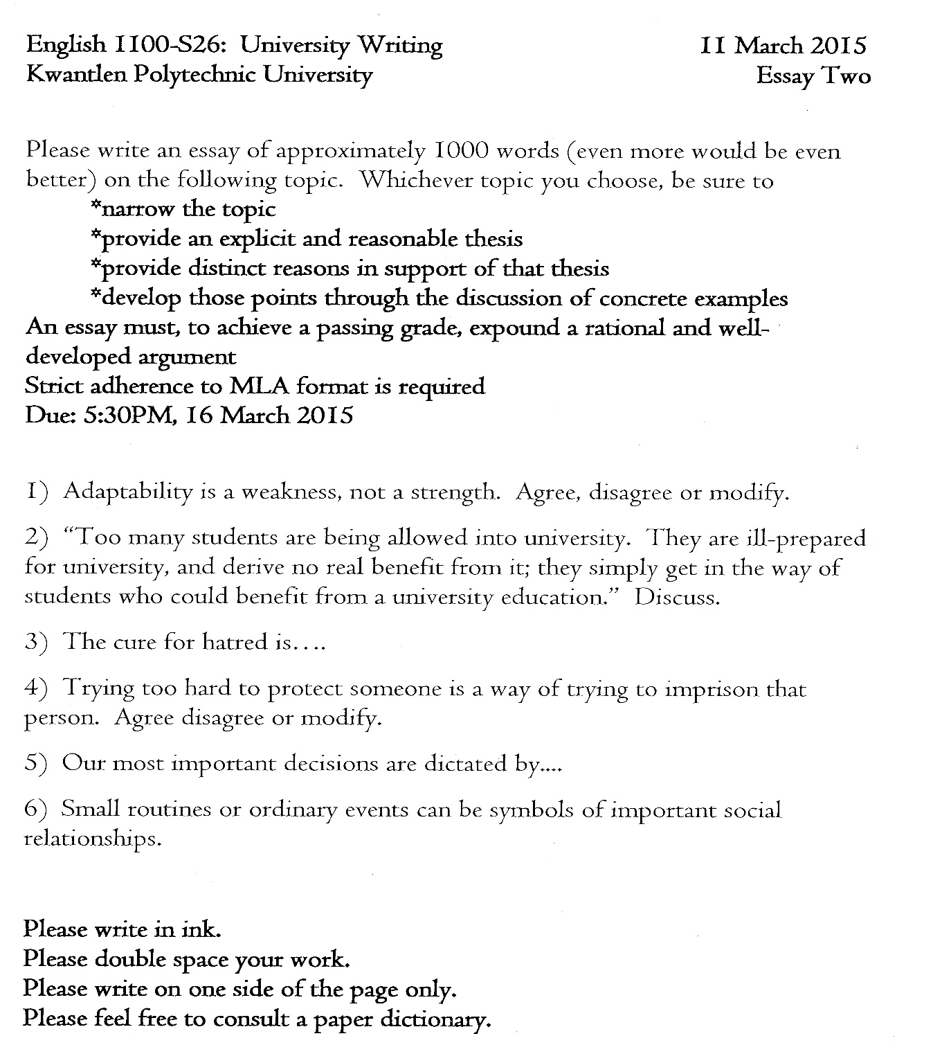

Practice Paper I
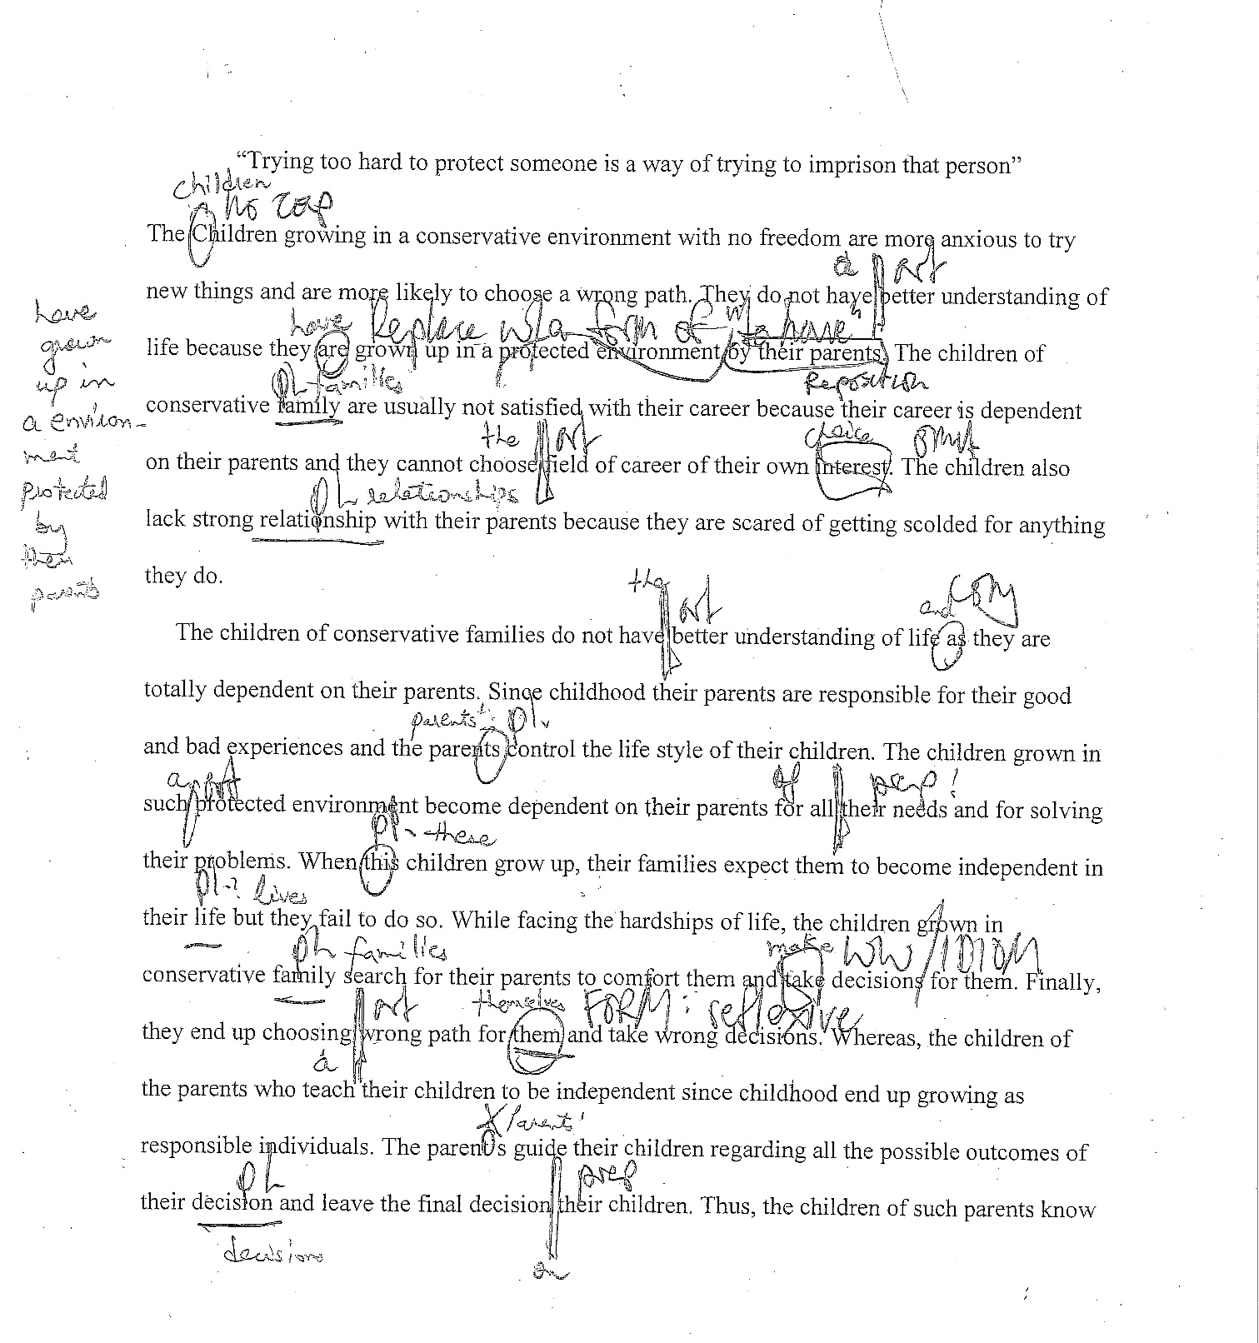
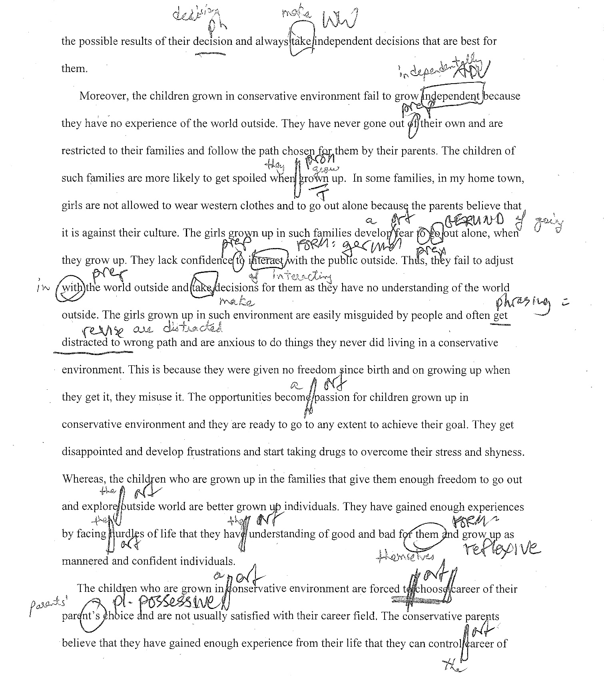
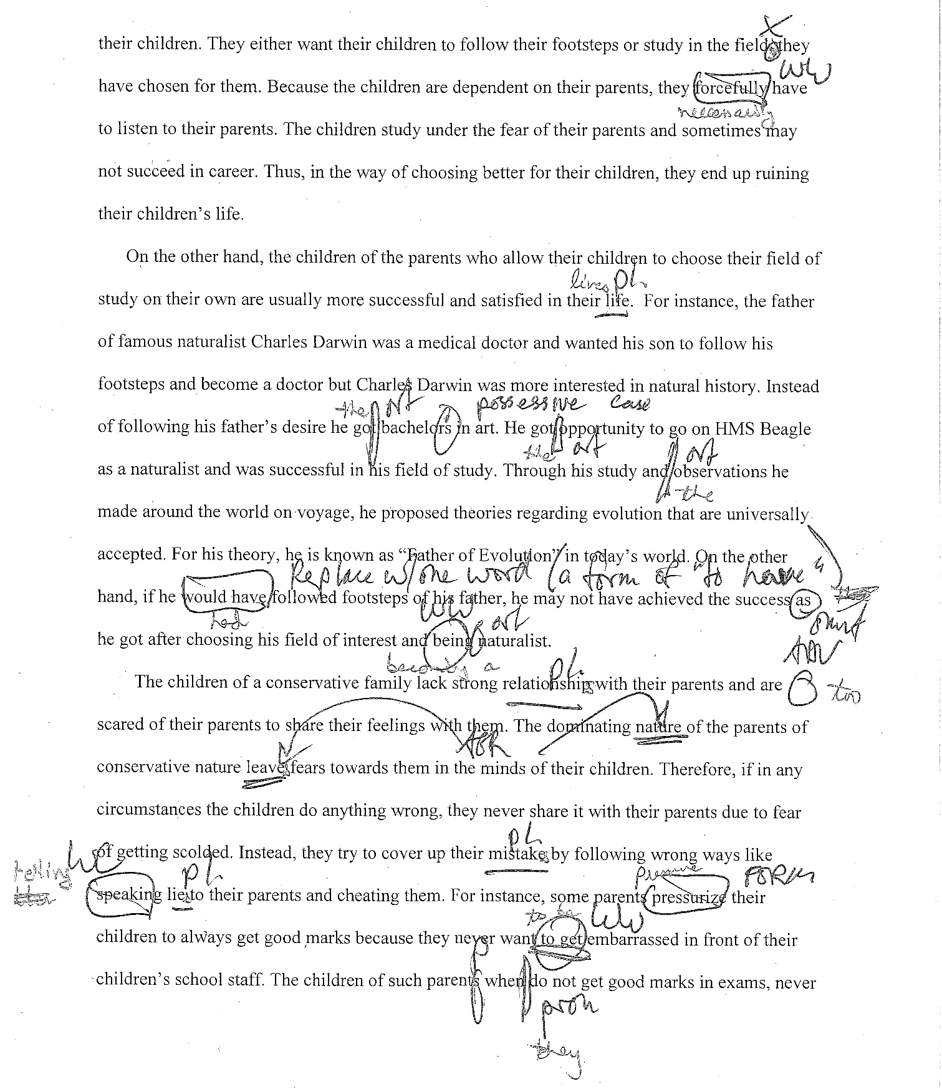
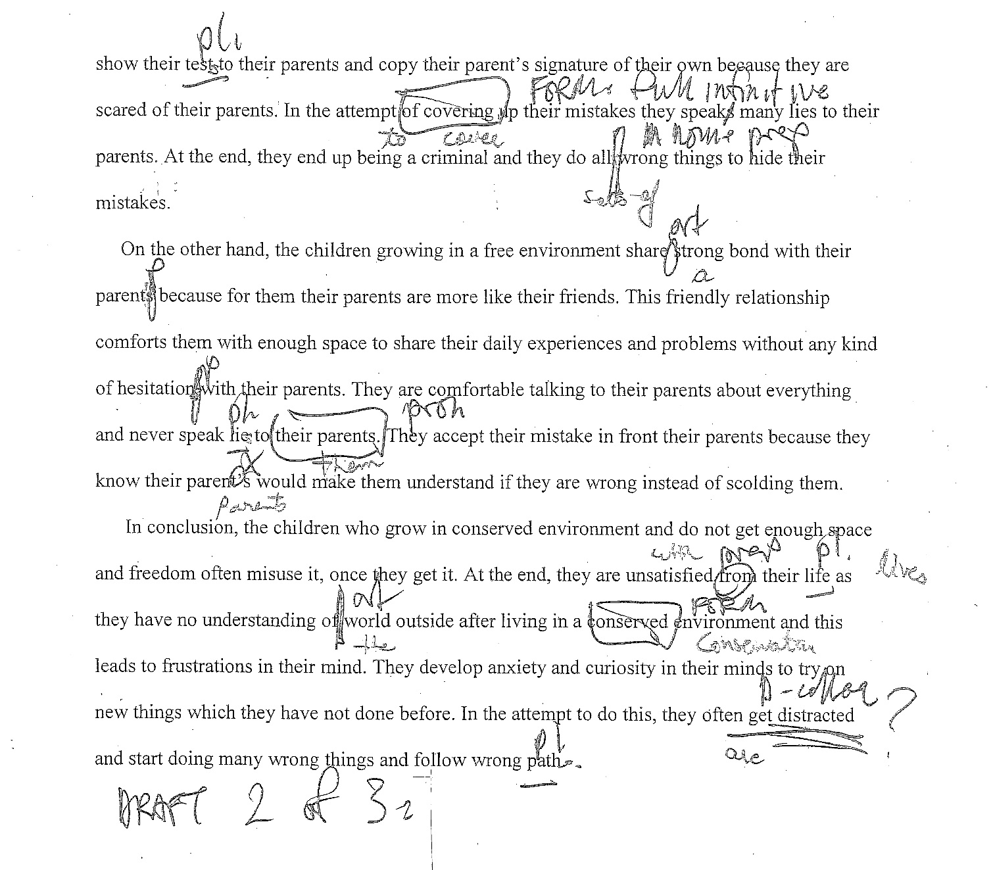

Notes and Questions

Develop Session Plans for Writing Tutoring
With a focus on your work as a Writing Tutor, you will do ongoing planning for your tutoring sessions. You will be sharing your plans with your Trainer, your Faculty Mentor, and with other Tutors who tutor in writing. They will be able to help you adapt your plans and questions to the most probable situations that you may encounter. Before you start your first tutoring session, you will have at least two plans that you could use (one you create in your Fundamental training and one you are now going to create).

Activity: Create a Session Plan for Writing Tutoring
Create a 30-minute tutoring session plan, using a writing topic.

Session Planning Template
1. Learning Objective – What the learner will be able to do upon mastery of this activity.
2. Anticipatory Set – Puts the tutee into a receptive frame of mind. Include what the learner already knows; review of other work that may relate to this new activity.
3. Input – Tutor presents new information, using specific materials related to objective and focusing on the necessary basic skills.
4. Modeling – Tutor shows the skill needed so that the tutee can then do it themselves. The tutee asks question and tries the skill.
5. Check for Understanding – Tutor checks that each step has been understood.
6. Guided Practice – Tutor provides opportunity to practice what has been presented. Effectiveness of the learning activity is evaluated and adjusted.
7. Closure – Tutor brings session to an appropriate conclusion with review and ensuring that the tutee has the main ideas.
8. Independent Practice – Tutor provides an activity to reinforce proficiency related to the stated objective.

Conduct Writing Tutoring Session Using the Tutoring Cycle
Now that you have developed a session plan, you will need to use it in a real tutoring situation where you can model problem solving. This is where to find out what works and start to adjust and change your plan as needed.
Steps of the Tutoring Cycle

Walsh, Benn, Macpherson 2019

Activity: Use the Tutoring Cycle in Writing
Connect your writing session plan with each of the steps in the tutoring cycle. Consider how you will approach each step and discuss this with a partner.

Activity: Analysis of Practice Paper II (p. 31)
A student has brought in what she hopes is the final draft of a paper for an Arts course. The appointment is for 30 minutes. The paper is due in one week. The student has taken two university level courses before, but almost every time she has written an essay or exam, instructors seemed vaguely disappointed and awarded a mediocre mark. The student is afraid that this will happen again. She doesn't want a mediocre mark on this paper that she has worked so hard on. This is her first time seeking assistance.
As a tutor, what do you think that you and the tutee should work on?

Activity: Working with Various Writing Difficulties
Tutee: Identify and describe in some detail a problem you are having at one stage in the writing process.
Writing Tutor: Model an appropriate strategy for that stage of the writing process from the strategies discussed.
After 10 minutes, stop and answer the following questions. Discuss what happened with your partner.
When you are the Tutor answer these questions:
- What method did I use to show the technique: lecture, modeling/demonstration, personal story of using the method, talking the tutee through using the technique on the composition, or some combination, or others?

- What was one strength of my tutoring?

- What is one area for improvement in my tutoring?

When you are the Tutee, answer these questions:
- Do you now know the technique well enough to use it independently?

- Do you think it is a worthwhile technique for you to use?

Reverse roles and repeat. You will answer the other set of questions the second time.

Practice Paper II
Starting with this unmarked paper, read and consider the type of feedback that you would give this writer. Where would you start?
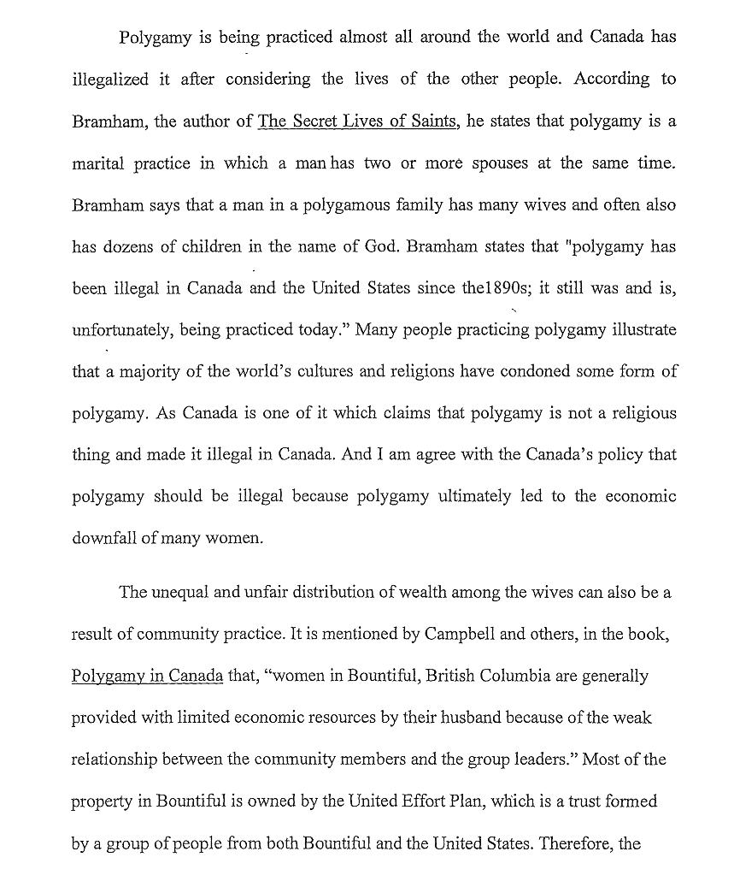
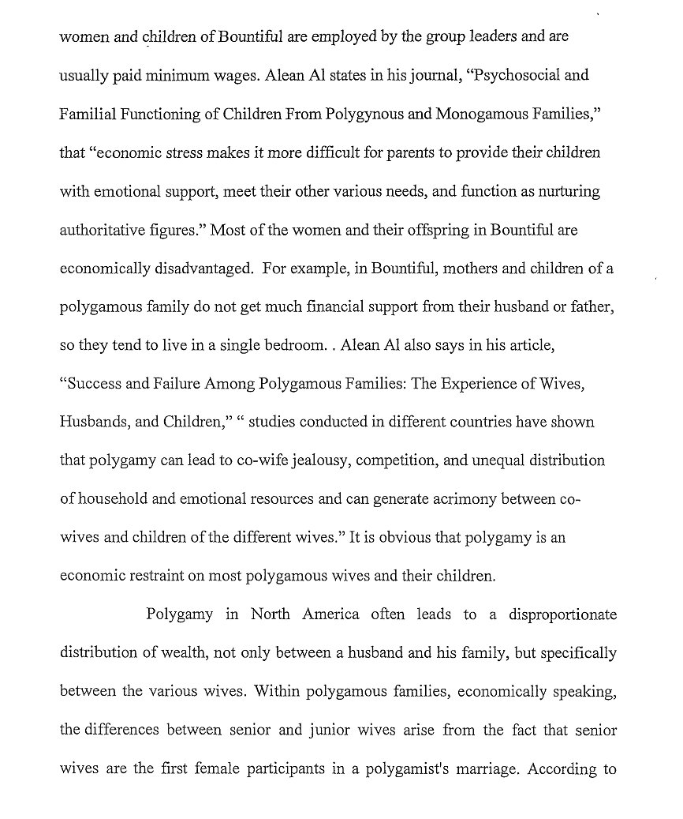
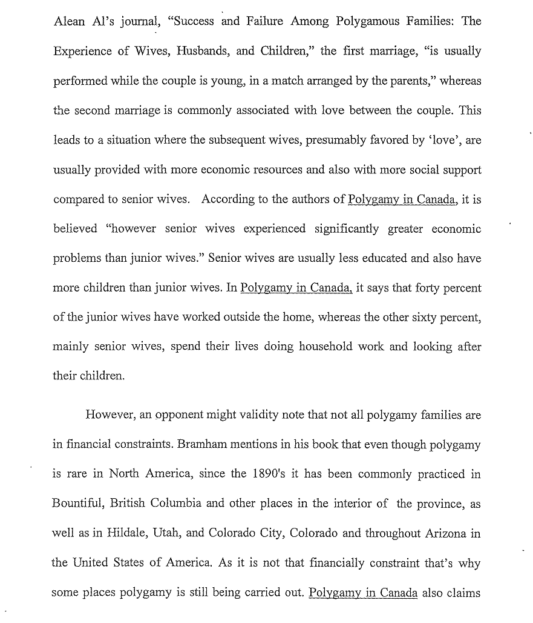
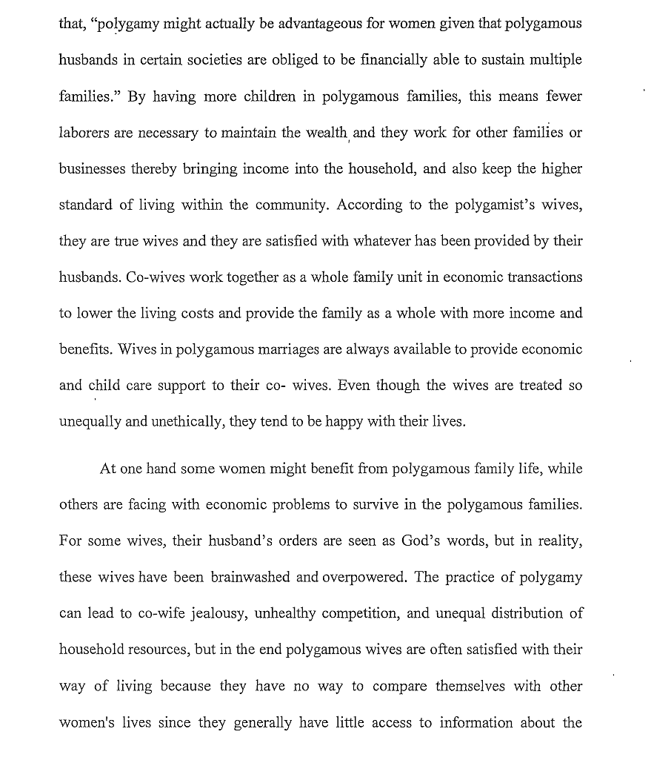
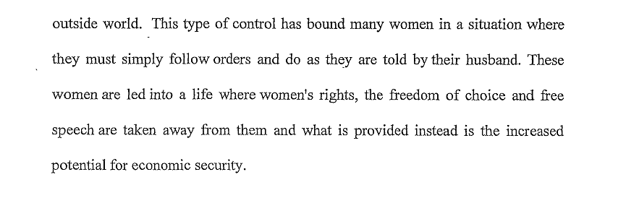

Notes and Questions:

Refer Tutees to Suitable Writing Resources
The Virtual Writing Centre at KPU has a wealth of resources to help students (and you) write better:
https://community.moodle.kpu.ca/course/view.php?id=53
More resources are available on the Learning Centre website:
Learning Aids – Writing Basics: https://www.kpu.ca/learningcentres/learning-aids#WritingBasics
English as a Second Language: https://www.kpu.ca/learningcentres/esl#writing

Activity: Identify Writing Resources that Help Tutees
Select two resources from the Virtual Writing Centre or the Learning Centre website and write a short statement about how you would use each resource as a writing tutor. Identify any questions that arise for you.

Notes and Questions:

Notes and Questions:

Interact with Tutees as a Writing Tutor
After you have completed the Integration exercise Shadow Tutoring Sessions, you will debrief with your Trainer and the next step will be to start your official writing tutoring. The following outcomes will be a guide for all of your tutoring practice.

Tutor Fundamental Outcomes
KPU tutors will have the knowledge, skills, and ability to:
- follow Learning Centre recommended best practices and standards of service
- work independently with a diverse and widely-dispersed team in a tutoring environment
- use proficient communication skills in both oral and written English in a tutoring environment
- productively engage with accented non-standard English speakers
- adapt tutoring strategies and input to respond appropriately to differing learner needs
- balance the learners' expressed needs, the assignment instruction criteria, and the tutor's perceptions of the learning needs
- provide tutoring input that is feasible for learners to follow
- structure tutoring to conform to time limits and tutoring priorities
- search for, select, and demonstrate appropriate resources from a broad-range of academic materials
- judge when a referral is needed (when a request is beyond one's knowledge and ability 5
- framework) and effectively refer learners to appropriate resources
- employ ethical standards and practices which:
- encourage academic honesty
- encourage learner independence/responsibility
- adhere to the CRLA/ATP code of ethics (available at: http://www.crla.net/index.php/certifications/ittpc-international-tutor-training-program)
- maintain tutor role boundaries
- explain and apply KPU tutoring policies and procedures
- commit to ongoing development of tutoring skills through ongoing training programs

Writing Specialization Area Outcomes
In addition, Writing Tutors will also be able to:
- productively engage with writing from basic writing skills courses
- productively engage with accented non-standard English writing
- model and demonstrate effective writing strategies
- employ appropriate critical reading skills to effectively and efficiently identify and distinguish between higher and lower order concerns in the primary genres of academic writing assigned in North American post-secondary courses
- search for, select, and demonstrate appropriate resources from a broad-range of academic writing materials
- base tutoring responses in current writing centre theory and writing tutoring best practices
Adapted from WriteAway Competencies

Best of Tutoring Luck (which is a combination of knowledge, practice, and good management) as you become a Writing Peer Tutor.

