Minimal Risk, Course Based Research Application
All research at KPU that involves humans as subjects requires review by the KPU Research Ethics Board. Initiating this review process is now paperless through the KPU Romeo portal.
To complete your application for Human Ethics Review:
Login to the Romeo Researcher portal using your email address and password information.
- On the Home Screen, choose APPLY NEW.
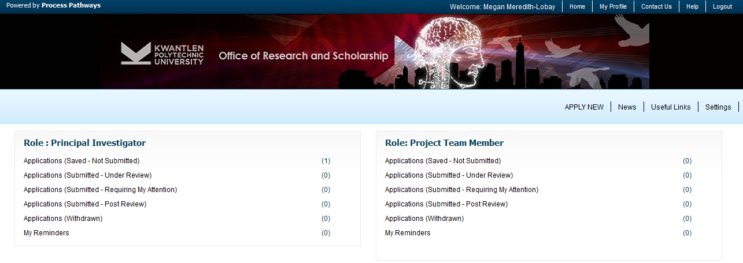
2. Under “Certification” choose “Minimal Risk, Course Based Research” and click to open.
NOTE: You will notice a variety of tabs at the top of the page – each of these tabs constitutes the application and must be completed before the application can be submitted.

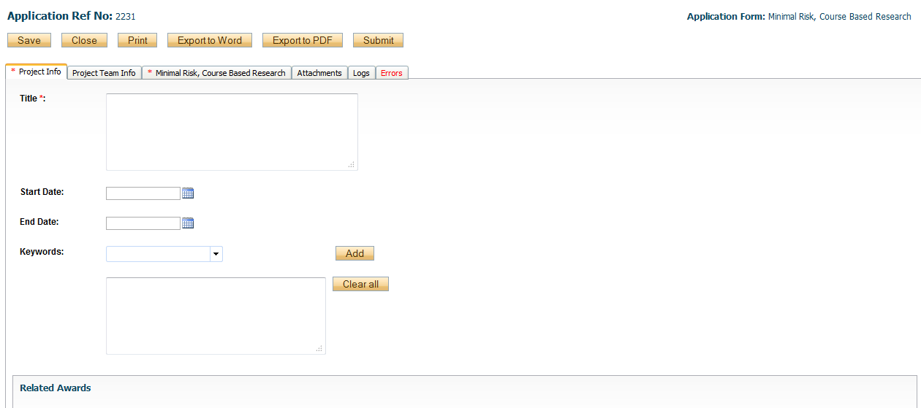

3. Fill out the Project Information including Project Title, Start and End dates.
NOTE: Start and end dates are the projected dates that you expect to begin/end your research.
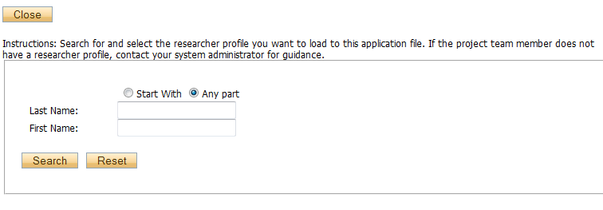
4. Related Awards: This is not normally applicable to Course-Based, but please do include any relevant information.
5. Complete the Project Team tab and include any team members that may be part of this research project/application.
IMPORTANT: If you have to change the P.I., ALWAYS choose from the list of investigators already in the system. If an investigator is added to the database twice, the system will have problems properly managing communications.
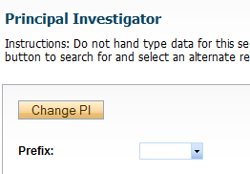
Search for additional team members by entering his/her first or last name at the top of the screen and clicking “Search.” If team members are not in the system database, please contact the REB Coordinator, reb@kpu.ca, in order to have them added.
6. Click on the “Minimal Risk, Course Based Research” tab and complete the questions. Click on each tab within the application form and fill in all required fields. Ensure you scroll down to the bottom of the page and answer all the questions on each tab. Scroll back to the top of the page to continue to the next tab.
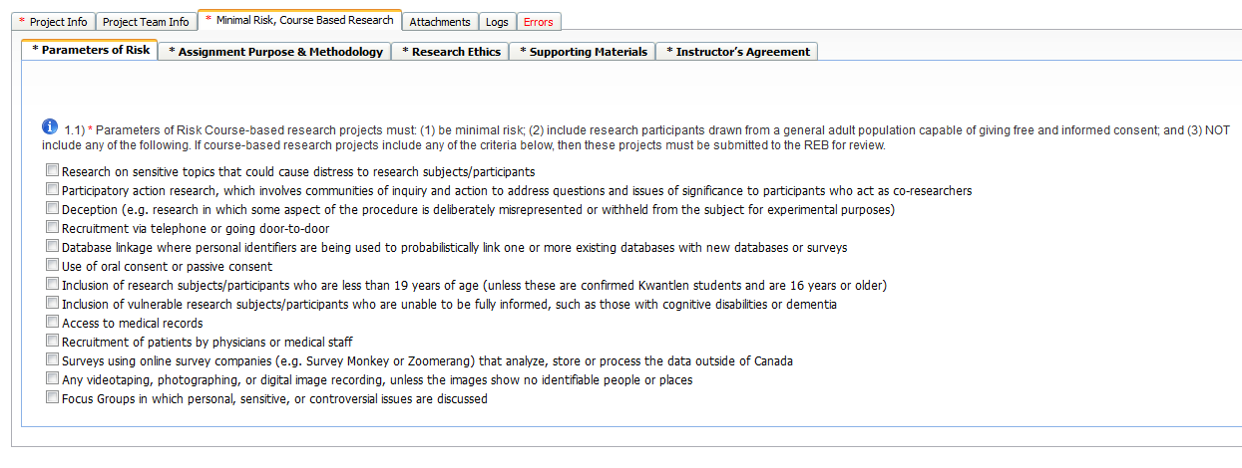

NOTE: All questions with a red asterisk require responses. If the question is a yes/no question and your response does not require explanation, simply respond “no”.
7. Use the Attachments tab to include/upload additional documents that need to accompany your application.
8. The Errors tab indicates fields that need to be completed before the application can be successfully submitted. The Errors tab will disappear once all required fields have been completed at which time the application can be successfully submitted.
9. Once you have completed all required information, you will be free to Submit your application using the top, right hand submit button. When you hit “Submit” the application will automatically be forwarded to the Research Office for further processing. You will receive email confirmation that your application has been successfully submitted and will be able to follow the application through the approval process by viewing the Logs tab within the application.
NOTE: When you have clicked “Submit” a “Comments” box will appear. You must type something in this box to proceed with submission.

