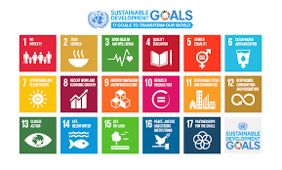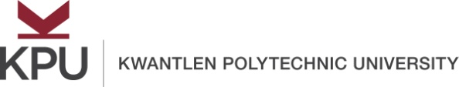

United Nations Sustainable Development Goals
Open Pedagogy Faculty Fellowship
Description

Open educational resources (OER) increase equitable access to education and empower students in the learning process. Open pedagogy – an approach to teaching and learning that draws on OER – places the student at the center of that learning process in a more engaging, authentic, and collaborative learning environment in order to achieve social justice in the community. Kwantlen Polytechnic University (KPU) and Montgomery College (MC) in Montgomery County, Maryland (U.S.A.) are committed to supporting social justice through this first-ever international partnership in which faculty can work across institutions to maximize global impact.
The conceptual framework on which this fellowship is based is the United Nations Sustainable Development Goals (UN SDGs), which is a set of 17 goals that address a wide range of social issues, such as poverty, inequality, climate change, and peace and justice. The SDGs are designed to achieve and maintain social justice and a sustainable future, with a target of the year 2030 set for the attainment of each goal.
This fellowship is designed to assist faculty with creating renewable assignments (all of which will carry a Creative Commons license) to help them become agents of change in their own communities. Each fellowship team (which will include at least one faculty member from KPU and one faculty member from MC) will begin to design three renewable assignments in Summer 2019. A minimum of two renewable assignments will be deployed in the classes of each fellowship team during the 2019-20 academic year. Faculty will be expected to present to the KPU community at appropriate venues (e.g., Teaching, Learning, Scholarship, & Research Symposium) on their renewable assignments. A student showcase will take place during Spring 2020 (tentatively planned for Tuesday, February 25, 2020) in which a select number of students will present on how they improved their communities and achieved global justice through the UN SDG framework.
It is anticipated that 2 applications will be selected for the UN SDG Open Pedagogy Fellowship, which includes training and support from the Office of Open Education along with a grant of CDN$1000 that may be used to hire one or more student assistants. Open Pedagogy Fellows will be required to attend a kick-off meeting and three additional meetings throughout the summer:
- Thursday, May 30 Kick-off Meeting 1:00-3:30 p.m.
- Thursday, June 6 1:00-3:30 p.m.
- Thursday, June 13 1:00-3:30 p.m.
- Thursday, August 1 1:00-3:30 p.m.
KPU faculty interested in becoming a UN SDG Open Pedagogy Faculty Fellow should discuss their interest with the Rajiv Jhangiani, Special Advisor to the Provost on Open Education. There will be priority consideration for applications for teams, including interdisciplinary teams. Communications with MC faculty and students can be done entirely through web conferencing and/or email. Completed applications must be endorsed by the Dean of your Faculty and submitted to open@kpu.ca by midnight on April 1, 2019. Applications will be adjudicated by the Open Education Working Group. Faculty will be notified of acceptance into the fellowship the week of April 8, 2019.
For questions, please contact:
Dr. Rajiv Jhangiani: Rajiv.Jhangiani@kpu.ca
Dr. Michael Mills: Michael.Mills@montgomerycollege.edu
Professor Shinta Hernandez: Shinta.Hernandez@montgomerycollege.edu

United Nations Sustainable Development Goals
Open Pedagogy Faculty Fellowship
Application Form

Lead applicant’s name: ___________________________________________________________
Lead applicant’s email address: ____________________________________________________
Note: Fellowship applications may be made by individual faculty or by teams of faculty. If your application includes additional members, please list them here:
Additional Team Members | Department(s) | Proposed Course(s)

Please answer the following questions:
Question 1: Which sustainable development goal is your application designed to serve?

Question 2: In one paragraph, describe how open pedagogy might benefit your students in your proposed course(s).

Question 3: In one paragraph, describe how open pedagogy might benefit your discipline.

Question 4: Describe other reasons why you would be interested in becoming a UN SDG Open Pedagogy Faculty Fellow.

Applicant’s Signature:
Date:

Dean’s Signature of Support:
Date:

Renewable assignments (also known as non-disposable assignments) are those that add value to a student's world, live outside of the boundaries and beyond the duration of the course, and are likely to have a lasting impact. Disposable assignments, on the other hand, are those that only the instructor and students will see and which students are likely to throw away once they have been graded (Seraphin et al., 2019; Wiley, 2013).

