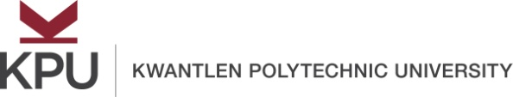

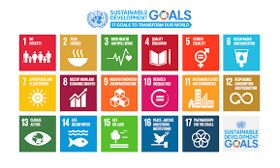

United Nations Sustainable Development Goals
Open Pedagogy Faculty Fellowship Description
Summer 2020

Open educational resources (OER) increase equitable access to education and empower students in the learning process. Open pedagogy – an approach to teaching and learning that draws on OER – places the student at the center of that learning process in a more engaging, authentic, and collaborative learning environment in order to achieve social justice in the community. Kwantlen Polytechnic University, Montgomery College (Maryland, USA), and Maricopa Community Colleges (Arizona, USA) are committed to supporting social justice through this international partnership in which faculty can work across institutions to maximize global impact.
The conceptual framework on which this fellowship is based is the United Nations Sustainable Development Goals (UN SDGs), which is a set of 17 goals that address a wide range of social issues, such as poverty, inequality, climate change, and peace and justice. The SDGs are designed to achieve and maintain social justice and a sustainable future, with a target of the year 2030 set for the attainment of each goal.
This fellowship is designed to assist faculty with creating renewable assignments (all of which will carry a Creative Commons license) to help them become agents of change in their own communities. Each fellowship team (which will include at least one faculty member from KPU and one faculty member from either Montgomery College or Maricopa Community Colleges) will begin to design three renewable assignments in Summer 2020. A minimum of two renewable assignments will be deployed in the classes of each fellowship team during the 2020-21 academic year. Faculty will be expected to present to the KPU community at appropriate venues (e.g., Teaching, Learning, Scholarship, & Research Symposium) on their renewable assignments. A student showcase will take place during Spring 2021 (tentatively planned for Tuesday, February 23, 2021) in which a select number of students will present on how they improved their communities and achieved global justice through the UN SDG framework.
It is anticipated that up to 10 teams will be selected for the UN SDG Open Pedagogy Fellowship, which includes training and support from the Office of Open Education. Open Pedagogy Fellows will be required to attend a kick-off meeting and three additional meetings throughout the summer:
- Tuesday, May 26 Kick-off Meeting 10:00am-1:00pm
- Wednesday, June 10 10:00am-1:00pm
- Wednesday, June 24 10:00am-1:00pm
- Wednesday, August 12 10:00am-1:00pm
KPU faculty interested in becoming a UN SDG Open Pedagogy Faculty Fellow should discuss their interest with the Rajiv Jhangiani, Associate Vice Provost, Open Education. There will be priority consideration for applications for teams, including interdisciplinary teams. Communications with Montgomery College/Maricopa Community Colleges faculty and students can be done entirely through web conferencing and/or email. Completed applications must be endorsed by the Dean of your Faculty and submitted to open@kpu.ca by midnight on March 30, 2020. Applications will be adjudicated by the Open Education Working Group. Faculty will be notified of acceptance into the fellowship the week of April 6, 2020.
For questions, please contact:
Rajiv Jhangiani: Rajiv.Jhangiani@kpu.ca
Michael Mills: Michael.Mills@montgomerycollege.edu
Shinta Hernandez: Shinta.Hernandez@montgomerycollege.edu
Matthew Bloom: Matthew.Bloom@scottsdalecc.edu
Deborah Baker: Deborah.Baker@domail.maricopa.edu
Carla Ghanem: Carla.Ghanem@gatewaycc.edu

United Nations Sustainable Development Goals
Open Pedagogy Faculty Fellowship Application Form
Summer 2020

Lead applicant’s email address: ____________________________________________________
Team Members | Department(s) | Proposed Course(s) | Proposed SDG

Please answer the following questions:
Question 1: In one paragraph, describe how open pedagogy might benefit your students in your proposed course(s).

Question 2: In one paragraph, describe how open pedagogy might benefit your discipline.

Question 3: Describe other reasons why you would be interested in becoming a UN SDG Open Pedagogy Faculty Fellow.

Applicant’s Signature:
Date:
Dean’s Signature:
Date:

Renewable assignments (also known as non-disposable assignments) are those that add value to a student's world, live outside of the boundaries and beyond the duration of the course, and are likely to have a lasting impact. Disposable assignments, on the other hand, are those that only the instructor and students will see and which students are likely to throw away once they have been graded (Seraphin et al., 2019; Wiley, 2013).

